

**MADDA WALABU UNIVERITY**

**COLLEGE OF COMPUTING**

**DEPARTMENT OF INFORMATION SCIENCE**

Title:Web -Based Online Shopping System for Abenezar electronics

Final Project students phase I

Submitted to the College of computing in partial fulfillment of the requirements for the degree of Bachelor of Science in Department Information Science

**By:**

Gadisa Tegene…………………………………ugr/34494/14

Kumesa Balisa…………………………………ugr/31314/14

Advisor: - Mr.Amanuel.B

May, 2017

*Robe ,Ethiopia*

Declaration

The Project is our own and has not been presented for a degree in any other university and all

the sources of material used for the project have been duly acknowledged.

Name of Students Signature Date

1. Gadisa Tegene ________________ ____________

2. Kumesa Balisa ________________ ____________

This is to certify that I have read this project and that in my opinion it is fully adequate, in scope and quality, as a project for the degree of Bachelor Department of Information Sciences.

Name of Advisor Signature Date

Amanuel.B __________ ________________ _________

Examining committee members Signature Date

1. __________________ ________________ _________

2. __________________ ________________ _________

Approval Sheet

Project Title: Web-Based Online shopping System for Abenezar Electronics .

Name of Students Signature Date

1. Gadisa Tegene ____________ __________

2. Kumesa Balisa ______________ __________

Advisor Signature Date

_______________________ ______________ __________

Examiner Signature Date

_______________________ ______________ __________

Project Coordinator Signature Date

_______________________ ______________ __________

# Abstract

##### Online electronics shopping system is mainly designed for Abenezar Electronics Shop and customer to buy items simply. The main objective of this system is to make buying and selling process interactive and easy to use. It makes searching, viewing and selecting a product easier. It contains sophisticated search methods for users to search items they want. The user can then view the complete detail of each product. The system also provides user to add a product to the shopping cart by selecting the item they want to buy. The main emphasis lies in providing customer to order item in easy way by using add to cart or select one item .The system generates receipt when customer successfully orders the item.

# 

# Acknowledgment

First of all we give praise for our God, who brought us to accomplish our job and who has given us success, helping us to pass safely through many difficulties.

we would also like to forward our sincerely appreciation and gratitude to our advisor, **Mr. Amanuel Birhanu** for his priceless patience whole hearted encouragement and for his effort on each and every activities of the project by advising, giving technical guidelines, helpful comments and suggestions for the completion of this project as we need.

Next we would like to thank the Project Coordinator **Mr.Chala.B** and employees of Abenezar Electronics shop for their contribution and support by giving different information about the shop.

# Table of Contents

Declaration **Error! Bookmark not defined.**

Abstract I

Acknowledgment III

Table of Contents IV

List of Figures VIII

List of Tables X

List of acronyms XI

CHAPTER ONE 1

INTRODUCTION 1

1.1BACKGROUND OF THE PROJECT 1

1.2STATEMENT OF THE PROBLEM 1

1.3.1 General Objective 2

1.3.2 Specific Objectives 2

1.4 Scope of the Project 4

1.5 Significance of the Project 4

1.6 Methodology and Tools 5  
  
1.6.2 System analysis and design and methodology.............................................................................................5

1.6.3 System Development Tools 5

1.6.3.1 Hardware Requirements 6

1.7.1 Project Management Technique 7  
  
1.7.1 Project schedule..........................................................................................................................................7

1.7.2 Project Budget(Cost Breakdown Estimation) 8

1.7.3 Work Breakdown Structure (WBS) Responsibility, and Deliverables 9

1.7.4 Risk Analysis Identification, Mitigation, and Monitoring 10

1.8 Feasibility of the Project 11  
  
1.8.1 Economic feasibility...................................................................................................................................11  
  
1.8.2 Technical feasibility...................................................................................................................................12  
  
1.8.3 Schedule feasibility.....................................................................................................................................12  
  
1.8.4 Operational feasibility................................................................................................................................12

[CHAPTER TWO STUDY OF THE EXISTING SYSTEM   
2.1 INTRODUCTION 1](#_Toc28774)3  
  
2.2 Literature review............................................................................................................................................13

2.3 Description of the Existing System 14

2.4 Drawbacks of the Existing System 14

2.5 Practices to Be Preserved from the Existing System 15

2.6 Business Rules 15

2.7 Forms Used in the Existing System 16

CHAPTER THREE 17

THE PROPOSED SYSTEM 17

3.1 OVERVIEW OF THE PROPOSED SYSTEM 17

3.2 System Constraints 18

3.3 Functional Requirements 20

3.4 Non-functional Requirements 21

3.5 Graphical user interface 22

3.5.1 Specification 22

3.5.2. User interface description 23

3.5.3 User Interface prototype(snap shoot) 25

3.6 Security and safety procedure User 26

CHAPTER FOUR 28

SYSTEM MODELING 28

4.1 INTRODUCTION 28

4.2 Actor identification 28  
  
4.3 use case identification....................................................................................................................................28

4.4. System use case diagram 31

4.4.1 Use case documentation 39

4.5 Dynamic Modelling 50

4.5.1.Sequence Diagram 50

4.5.2. Collaboration Diagram 59

4.5.3. Activity Diagram 64

4.5.4 State Chart Diagram 71

4.6 Object modelling/static/conceptual modelling 73

4.6.1 Class Diagram 73

CHAPTER FIVE 75

SYSTEM DESIGN 75

5.1 INTRODUCTION 75

5.2 Architectural Design 75

5.2.1 Component modeling 76

5.2.2 Deployment Modeling 77

5.3. Database design 78

5.3.1 ER Diagram Design 78

5.3.2 Database Normalization 79

5.3.3 Persistent modeling 80

5.4 Data flow Diagram 82

Appendices 84

References 85

# List of Figures

Figure 1.7.1 :Gant Chart Project Schedule 7

Figure 3.1.: user interface prototype..............................................................................................................................25  
Figures 4.4.1:use case diagram online shopping 31

Figures 4.4.2:use case diagram Admin panel 32

Figures4.4.3:use case diagram customer workflow 32

Figures:4.4.4use case diagram product management (admin) 33

Figures 4.4.5:use case diagram order management 33

Figures4.4.6:use case diagram customer acount 33

Figures4.4.7:use case diagram product search & filtering 34  
Figures4.4.8:use case diagram customer checkout & payment 34

Figures 4.4.9:use case diagram customer order History 34

Figures 4.4.10:use case diagram Admin user 35

Figures4.4.11:use case diagram product Review 35

Figures4.4.12:use case diagram wishlist 36

Figures 4.4.13:Figures:use case diagram Admin order 36

Figures 4.4.14:use case diagram customer&Authentication 36

Figure 4.4.15: Use case diagram 37

Figure 4.5.1.1: sequence diagram for login 49

Figure 4.5.1.2: sequence diagram for change password 50

Figure 4.5.1.3: sequence diagram for view item 52

Figure 4.5.1.4: sequence diagram for order item 52

Figure 4.5.1.5: sequence diagram for update item 53

Figure 4.5.1.6: sequence diagram for register item 54

Figure 4.5.1.7: sequence diagram for register employee 55

Figure 4.5.1.8: sequence diagram for manage employee account 56

Figure 4.5.1.9: sequence diagram for generate report 57

Figures 4.5.2.1: collaboration diagram place order 58

Figures 4.5.2.2: collaboration diagram user regstitraction 59

Figures 4.5.2.3: collaboration diagram manager orders 59

Figures 4.5.2.4: collaboration diagram customer search & view 60  
Figure 4.5.2.5 collaboration diagram proccess..............................................................................................................61

Figures 4.5.2.6: collaboration diagram Admin adds 61

Figures 4.5.2.7: collaboration diagram customer tracks order 62

Figures 4.5.2.8: collaboration diagram customer request 62  
Figure 4.5.3.1 activity diagram for log in......................................................................................................................63

Figures 4.5.3.2 activity diagram for create account 64

Figures 4.5.3.3 activity diagram for change password 64  
Figure 4.5.3.4 activity diagram for search item.............................................................................................................65

Figure 4.5.3.5 activity diagram for view item 65

Figure 4. 5.3.6 activity diagram for order item 66

Figure 4.5.3.7 activity diagram for view order 66

Figure 4.5.3.8 activity diagram for update item 67

Figures 4.5.3.9 activity diagram for register item 67

Figures 4.5.3.10 activity diagram for register seller 68

Figures 4. 5.3.11 activity diagram for manage employee account 68

Figures 4.5.3.12 activity diagram for generate report 69  
Figure 4.5.3.13activity diagram for logout...................................................................................................................69  
Figure 4.5.4.:state chart diagram...................................................................................................................................71  
Figure 4.6.1.: obeject diagram.......................................................................................................................................73  
Figure 5.2.1,:componet diagram....................................................................................................................................75

Figures 5.2.2: Deployment diagram 76

Figures 5.3.1 ER Diagram Design 77

Figures 5.3.2: Class diagram for online shopping 79

Figure 5.3.3: Persistent diagram 80

Figures 5.3.4 Data flow Diagram 82

# List of Tables

Table 1.6: developing environment and programming tools 6

Table 1.7.2: Hardware and software cost 8

Table 1.7.3 Work Breakdown Structure 10

Table 1.7.4 Risk Analysis Identification 11

Table:4.1:Actor identification 28

Table:4.2:Customer Use Cases 29

Table:4.3:Customer Use Cases 29

Table 4.4.Admin Use Cases 30

Table 4.5: Delivery Staff Use Cases 30

Table 4.6 System Automated Use Cases 30

Table 4.4.1: use case description for login 38

Table 4.4.2: Use case description for change password 39

Table 4.4.3: Use case description for search item 40

Table 4.4.4: Use case description for view item 40

Table 4.4.5: Use case description for order item 41

Table 4.4.6: Use case description for view order 42

Table 4.4.7: Use case description for update item 42

Table 4.4.8 :Use case documentation for register item 43

Table 4.4.9 Us case documentation for register employe 43

Table 4 .4.10:Use case documentation for manage seller account 44

Table 4.4.11: Use case documentation for charge balance 44

Table 4.4.12: Use case documentation for transfer balance 45

Table 4.4.13 Use case documentation for generate report 46

Table 4.4.14: Use case documentation for logout 46

Table 4.4.15: Use case documentation for generate card 47

Table 4.4.16 Use case documentation for deliver item 47

Table 4.4.17 Use case documentation for return item 48

Table 4.4.18: Use case documentation for payment 48

# 

# List of acronyms

TV Television

GUI Graphical User Interface

NFR Non-Functional Requirement

TB Terabyte   
 RAM Random Access Memory   
 GB Gigabyte   
 DB Database   
 UML Unified Modeling Language   
 OOAD Object-Oriented Analysis and Design

WBS Work Breakdown Structure

UI User Interface

SQL Structured Query Language

XSS Cross-Site Scripting

CSRF Cross-Site Request Forgery   
 2FA Two-Factor Authentication   
 API Application Programming Interface

PERT Program Evaluation and Review Technique

HTTP Hypertext Transfer Protocol

HTTPS Hypertext Transfer Protocol Secure

# 

# CHAPTER ONE

# INTRODUCTION

## 1.1BACKGROUND OF THE PROJECT

Abenezar shop is located in Bale robe Town, capital city of bale zone , which is 432km

far away from Addis Ababa. The establishment of Abenezar shop was on 2004 E.C. The   
owner of the Shop is Mr. Gadisa and Mr. kumsa. Abenezar Electronics is a retail business that deals in electronic devices such as smartphones, laptops, televisions, and accessories. Currently, the business operates through a traditional in-person sales system which limits customer reach and operational efficiency. In today's competitive market, an online presence is vital for business growth and customer satisfaction. This project is initiated to design and implement an online shopping system tailored for Abenezar Electronics. The system will automate product listings, order processing, payment transactions, and delivery tracking. By integrating technology into business operations, the project aims to improve service delivery and expand the company’s market coverage.  
Therefore the system we do to analyze in this project is about Abenezar Shopping management system. We try the best way to make the complicated process of robe Shopping Management System as simple as possible using Structured & Modular technique & Menu oriented interface. We are going to design the website in such a way that customer may not have any difficulty in using this package & further expansion is possible without much effort. Even though we cannot claim that this work to be entirely exhaustive, the main purpose of this project is to make each customers and workers activity in computerized way rather than manually which is time consuming. (Laudon, 2020)

## 1.2 STATEMENT OF THE PROBLEM

The current sales and inventory management system at Abenezar Electronics is completely manual. Customers must visit the store physically to browse products or make purchases, which is time-consuming and inconvenient. Many customers do not even know what goods are available, as there is no catalog or online listing. The business also lacks an efficient system to manage orders, track sales, or maintain digital customer records. This leads to inefficiencies such as product mismanagement, slow service, and poor customer follow-up. Additionally, the shop operates only within Bale Robe, restricting access to customers outside the city and severely limiting the company’s market reach and growth potential. Generating accurate reports is difficult due to the manual, paper-based nature of the system, which also results in a high risk of data loss, duplication, and inconsistency. The system does not support 24-hour operation, reducing service availability and convenience for customers. Furthermore, customers often have to register repeatedly because there is no centralized customer database, leading to redundancy and frustration. The system also lacks proper security measures, as it does not have a centralized or protected database, leaving sensitive data exposed and vulnerable. Payments are accepted only in cash, with no support for online transactions or digital receipts, which limits both customer convenience and financial tracking for the business. The lack of automation also hinders timely updates on order status or inventory availability. In summary, the major problems with the existing system include limited customer reach, time-consuming and error-prone manual processes, lack of 24/7 accessibility, repetitive user registration, poor customer engagement, no digital payment integration, and serious security and data management concerns. To address these challenges, this project proposes the development of a modern, web-based online shopping system that will allow customers to conveniently browse products, place orders, make secure payments, and receive digital receipts. It will also enable the business to manage inventory in real time, automate operations, and improve customer relationship management — ultimately enhancing both efficiency and customer satisfaction.  
 1.3 Objectives

### 1.3.1 General Objective

The general objective of this project is to develop interactive web based shopping system for Abenezar electronics shop to facilitate selling and buying process.

### 1.3.2 Specific Objectives

The specific objectives of this project are designed to address the identified problems and deliver a fully functional, user-friendly online shopping platform.

First, the system will enable customer account management by allowing users to register, log in, and securely manage their profiles. Customers will be able to update their personal information and change their passwords with ease.

Second, the platform will support advanced product browsing and search features. Users can search and filter products based on key attributes such as name, category, brand, and price range, ensuring a quick and effective product discovery experience.

Third, the system will allow customers to select items and complete their purchases through a streamlined process that includes adding products to a shopping cart, reviewing the selection, and proceeding through a checkout process.

Fourth, the solution will support secure and flexible online payment options, such as card-based transactions, balance transfers, or cash-on-delivery, with real-time confirmation to ensure a smooth transaction experience.

Fifth, the platform will offer robust inventory and product management capabilities for administrators and sellers. These features will include the ability to add, update, and remove items, manage categories, and track inventory in real time.

Sixth, administrative features will include control over user roles and system data, enabling staff to manage employee accounts, generate recharge cards for customer balances, and address product complaints or return requests efficiently.

Seventh, the system will be capable of generating meaningful reports. These will include sales performance summaries, product activity reports, and user engagement logs, which will aid decision-making and business evaluation.

Eighth, customers and staff will benefit from real-time order tracking capabilities. The system will provide updates on delivery status and maintain a comprehensive order history for reference.

Ninth, the platform will ensure accessibility by offering responsive and user-friendly interfaces across devices such as desktops, tablets, and smartphones. This approach will improve usability for customers in both urban and rural settings.

Lastly, the system will enhance security through secure authentication, session management, strict input validation, and data encryption to protect sensitive customer and transaction information.

To allow users to register, log in, and manage their profiles.

To enable browsing of products by categories, features, and price.

To facilitate adding products to a shopping cart and checking out.

To support secure online payment options.

To enable the admin to manage inventory, track orders, and monitor sales.

To generate reports for decision-making and performance analysis.

## 1.4 Scope of the Project

The system will focus on providing e-commerce functionality for Abenezar Electronics. It will include modules for user management, product management, order processing, payment handling, and reporting. The system will be developed as a web application accessible through standard browsers. It will support both customer and administrative operations but will not include mobile apps or third-party delivery integration in this phase.

## 1.5 Significance of the Project

This project has significant implications for improving business efficiency and customer satisfaction at Abenezar Electronics. It will reduce the time required for customers to shop and for staff to process orders. It will also help the business maintain accurate sales records, manage inventory effectively, and reach more customers through the internet. Overall, the system is expected to enhance productivity and profitability.  
1.5.1 Beneficiaries of project

## The beneficiaries of this project are- Customers:-gets fast access to see what types of goods they want. Manager: - System reduces time wastage and work load. Company: - Provide more effective system and reduce need of man power, increase number of customer and lose of paper because they use manual system. Group member:-to increase knowledge, skills and mental satisfaction.

## 1.6 Methodology and Tools

The methodology and tools used in the development of the "Online Shopping System for Abenezar electronics" project, including data collection, system analysis and design, and the tools used for system development.  
1.6.1 Data Collection Methodology

To ensure the successful development of the Online Shopping System for Abenezar Electronics, both primary and secondary data collection methods were employed.

**Primary Data Collection:**

This involved direct interaction with stakeholders to gather firsthand information. Structured and semi-structured interviews were conducted with the store manager, employees, and selected customers. The goal was to understand the current challenges of the manual system, user expectations, and specific needs of the business. Additionally, observation of daily activities was conducted to identify inefficiencies in the sales and inventory processes.

**Secondary Data Collection:**

This method involved the review of existing documents and records such as handwritten sales receipts, stock ledgers, and customer service logs. Literature related to online shopping systems, best practices in e-commerce development, and similar systems implemented in other regions was also consulted to inform the design and features of the proposed system.

The combination of these methods provided comprehensive insights into the existing challenges and the requirements for a functional and efficient e-commerce platform tailored to the needs of Robe Electronics.

* Primary and secondary data were collected through:

Interviews with staff at Abenezar Electronics

Surveys with existing customers

Review of documents and forms currently used by the busines  
1.6.2 System Analysis and Design Methodology

The system will be developed using the Object-Oriented Analysis and Design (OOAD) methodology. This approach facilitates modular and scalable system design through use cases, diagrams, and structured workflows.  
1.6.3 System Development Tools

The tools and technologies used for the development of this system are chosen based on their suitability for deep learning, web development, and system integration.

### 1.6.3.1 Hardware Requirements

* The hardware requirements for this project are as follows:
* Central Processing Unit (CPU)**:** A multi-core CPU (e.g., Intel Core i7 or AMD Ryzen 7) is necessary for data preprocessing and handling backend operations.

RAM: At least 8GB of RAM is required to handle large datasets and manage multiple processes efficiently.

•Storage: SSD storage with at least 1000GB of space is needed to store large image datasets, model checkpoints, and application files. SSDs will also improve the speed of training and model loading.

➢Server Requirements: For the web application, the backend server should have:

• Operating System: Window-based operating systems which are best for deployment due to their robustness and compatibility.

Database Server: A MySQL and XAMP database server to handle user data, image metadata, and diagnostic results.  
1.6.3.2 Software Requirement

# The following software tools and frameworks are used to develop and deploy the system: Tools and Technologies Table

|  |  |
| --- | --- |
| **Category** | **Tools/Technologies** |
| Platform | MS Windows Version 7 and 10 |
| Database | XAMPP MySQL |
| Programming Languages | Frontend: HTML, CSS, JavaScript, React.js Backend: Python, Node.js |
| Development Environment | Visual Studio Code (VS Code) |
| Version Control | Git |
| Documentation | MS Word |
| User Training & Presentation | MS PowerPoint |
| Modeling and Scheduling | Edraw Max, Visual Paradigm |
| Graphics Design Tools | Adobe Photoshop CS, Macromedia Flash |

##### Table 1.6: developing environment and programming tools

##### 

### 1.7.1 Project Management Technique

Effective project management is crucial to the success of the "Online Shopping System for Abenezar electronics. This section discusses the project management techniques used to ensure timely, cost-effective, and efficient delivery of the project, including scheduling, budgeting, task breakdown, and risk analysis  
1.7.1 Project Schedule  
The project schedule is essential for outlining the timeline for each phase of the project, including tasks, milestones, and deadlines. Two key project management tools will be used to ensure proper scheduling:

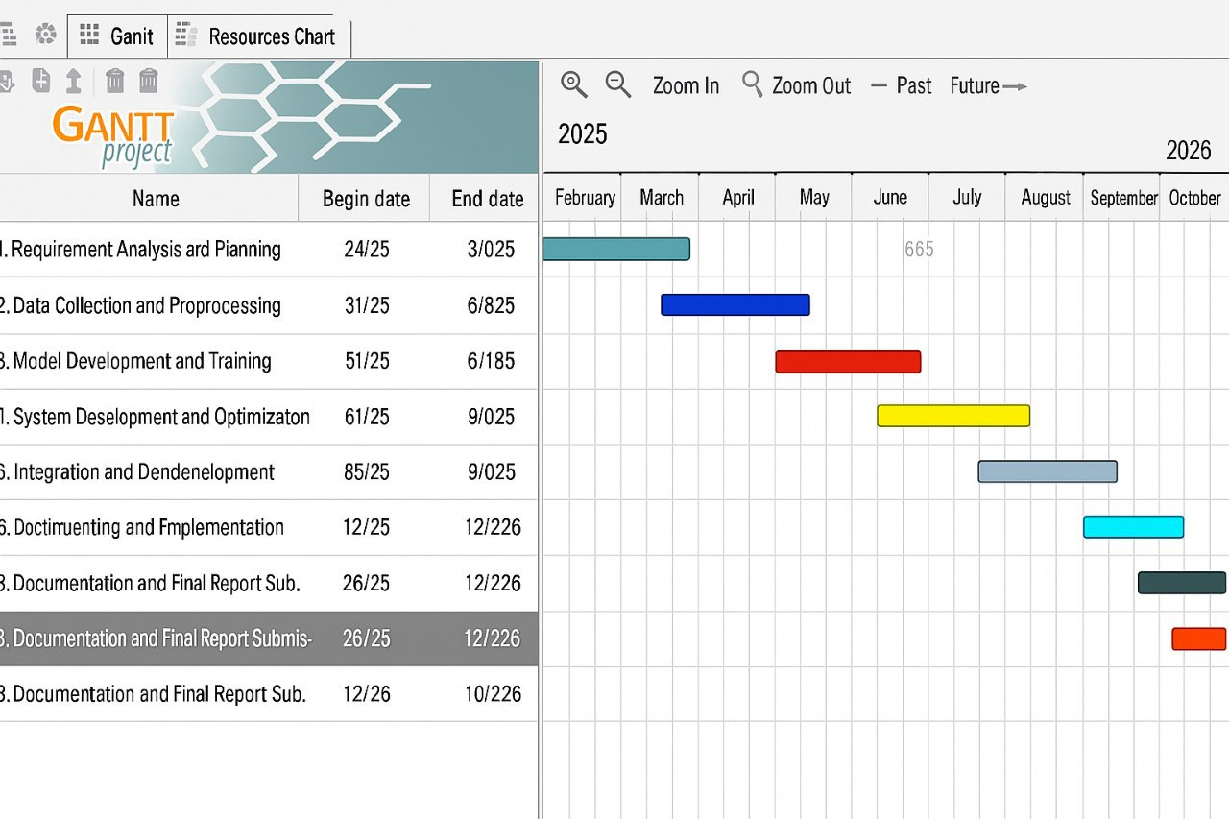

### ***Figure 1.7.1 :Gant Chart Project Schedule***

### 1.7.2 Project Budget(Cost Breakdown Estimation)

#### The project budget outlines the financial resources required for the successful completion of the project. The cost breakdown estimation for the "Online Shopping System for Abenezar electronics" project is divided into the following categories:

|  |  |  |  |  |
| --- | --- | --- | --- | --- |
| **Type** | List of item | Needed for | Quantity | Total cost |
| **Hardware required** | Pen and pencil | Writing the proposal | 10 | 100 |
| Binder | To take notes | 2 | 250 |
| Paper | To take notes | 1 dozen | 250 |
| Flash | To transfer data | 32GB | 350 |
| CD and DVD | For backup & recovery | 5 | 100 |
| Computer | To access software | 1 | 10,000 |
| **Software requirement** | Xampp server &php | To test the program locally | 2 | Free |
| Operating system win 10 |  | 1 | 50 |
| Microsoft office and power point | To store and present the project. | 2 | Free |
| Antivirus | For security | 1 | Free |
| Visual studio | For coding | 1 | Free |
| Edraw max | To show models | 1 | Free |
| Total | |  | 29 | 11,000 birr |

Table 1.7.2: Hardware and software cost   
  
**1.7.3 Work Breakdown Structure (WBS) Responsibility, and Deliverables**

The project is divided into tasks: requirement analysis, database design, interface development, backend development, testing, and documentation. Each task is assigned to responsible team members with expected deliverables.  
The work breakdown structure (WBS) provides a clear, hierarchical decomposition of the project into smaller, manageable components. The main tasks and responsibilities include

|  |  |  |  |
| --- | --- | --- | --- |
| **WBS Component** | **Tasks** | **Responsibility** | **Deliverables** |
| 1. Project Planning | Requirement gathering Feasibility analysis Project proposal and approval | Project Manager / System Analyst | Project proposal document Feasibility report Project charter |
| 2. System Design | UI/UX design Database design System architecture design | System Designer / Database Administrator | Wireframes and UI mockups ER diagrams System design document |
| 3. Front-End Development | Designing the user interface Responsive web pages | Front-End Developer | HTML/CSS/JavaScript code Fully responsive web interface |
| 4. Back-End Development | Develop product catalog and user authentication Admin and user panel Shopping cart and order management | Back-End Developer | Server-side scripts Functional modules |
| 5. Database Development | Product data storage User registration and order storage | Database Developer | Database schema Sample data and queries |
| 6. Testing and Debugging | Functional testing User acceptance testing Bug fixing | QA Tester / Developer | Test report Bug report Debugged final version |
| 7. Deployment and Hosting | Host website Domain registration System go-live | Deployment Engineer / Project Manager | Live website Hosting credentials Deployment report |
| 8. Documentation and Handover | Prepare user manual and technical documentation Final report and handover | Documentation Team / Project Manager | User guide Technical report Final documentation |

Table 1.7.3 Work Breakdown Structure

1.7.4 Risk Analysis Identification, Mitigation, and MonitoringThe risk analysis helps in identifying potential issues that could impact the project’s success.  
Below are the identified risks, their potential impacts, and mitigation strategies:

|  |  |  |  |
| --- | --- | --- | --- |
| **Risk Description** | **Risk Identification** | **Mitigation Strategy** | **Monitoring Plan** |
| System Downtime | Server crash or power failure during business hours | Use reliable hosting services, backup power systems | Regular uptime monitoring tools, emergency contact with hosting provider |
| Data Breach | Unauthorized access to user data or payment info | Implement encryption, secure authentication, firewall, regular updates | Routine security audits and penetration testing |
| Poor User Experience | Website is difficult to navigate or not responsive | Conduct user testing and feedback collection, optimize UI/UX | Regular usability assessments and feedback review |
| Inventory Errors | Mismatch between listed and actual stock | Integrate automated inventory management system | Daily sync and reports from inventory module |
| Payment Failures | Transaction errors or payment gateway downtime | Use reliable, multiple payment gateways | Track transaction logs and monitor gateway status |
| Delivery Delays | Shipping issues or vendor delays | Partner with reliable couriers, set clear delivery policies | Track delivery KPIs and handle complaints quickly |
| Project Overrun | Project goes beyond budget or schedule | Use proper planning, task estimation, and buffer time | Weekly project reviews and milestone tracking |
| Legal Compliance | Non-compliance with e-commerce regulations | Consult legal experts, follow national e-commerce laws | Regular legal reviews and documentation audits |

Table 1.7.4 Risk Analysis Identification

# 

# 1.8 Feasibility of the Project

# The feasibility analysis helps assess whether the project can be completed successfully considering various factors, including economic, technical, political, and operational aspects.

**1.8.1 Economic Feasibility**

The development of the online shopping system is considered economically feasible. Most of the development tools and platforms required for this project are open-source and freely available, minimizing initial costs. The investment needed for hardware and internet services is modest and justifiable considering the expected long-term benefits. These include increased customer reach, improved operational efficiency, and reduced labor costs, which together ensure the economic viability of the project.  
**1.8.2 Technical Feasibility**

This project is technically feasible as it utilizes technologies that are well-established, stable, and supported. The development team has access to the required technical expertise to design, build, and maintain the system. Additionally, the availability of local infrastructure, such as servers and stable internet, supports the successful implementation and operation of the system  
**1.8.3 Schedule Feasibility**

The proposed system can be completed within the academic timeline. A realistic schedule, divided into clearly defined phases such as planning, development, testing, and deployment, ensures that each milestone can be achieved on time. This structured approach helps manage time effectively and allows for any necessary adjustments during the development process.  
**1.8.4 Operational Feasibility**

The system is operationally feasible, as it is designed to align with the existing workflows at Robe Electronics. Staff and customers are expected to adapt easily due to the user-friendly interface and intuitive navigation. With minimal training, users will be able to efficiently interact with the system. Furthermore, the new system will enhance customer satisfaction and support the company’s day-to-day business operations.

CHAPTER TWO   
STUDY OF THE EXISTING SYSTEM  
2.1 INTRODUCTION

This chapter presents a comprehensive examination of the current operational system at Abenezar Electronics**,** with a particular focus on its manual processes and the challenges arising from the absence of automation. Abenezar Electronics, based in Robe City, serves customers from across the city and the surrounding Bale Zone. The business specializes in the retail of a diverse range of electronic products, including mobile devices, televisions, and accessories. However, in the absence of a digital platform, all customer interactions and transactions are conducted in person, requiring physical visits to the store. This manual approach significantly restricts the company’s market reach and impedes potential business growth, especially for customers living in remote areas of Bale Zone.

As consumer preferences increasingly shift toward convenience and online accessibility, the introduction of a web-based shopping platform becomes a strategic necessity. The proposed online shopping website is intended to transform the shopping experience for customers in Robe City and the wider Bale Zone, enabling them to access products without the need to travel. It will allow users to browse product categories, compare prices, place orders, and complete secure payments online—streamlining both the customer journey and business operations.

The primary objective of this chapter is to analyze the workflows, forms, and business rules governing the current manual system. It aims to identify operational inefficiencies and service limitations while uncovering opportunities for technological advancement. This analysis lays the groundwork for designing a responsive and user-friendly e-commerce solution that aligns with Abenezar Electronics’ business goals and the expectations of modern consumers across Bale Zone.  
2.2 Literature Review  
Online shopping systems have become essential in retail due to their convenience, efficiency, and scalability. According to various studies, e-commerce platforms enable businesses to reach broader markets, reduce operational costs, and improve customer experience. Common technologies in such systems include content management systems (CMS), secure payment gateways, and database-driven inventory systems. Learning from establish ed systems like Amazon, Jumia, and eBay, this project adapts key concepts for local implementation at Abenezar Electronics. (Chaffey, 2019)

## 2.3 Description of the Existing System

The current sales process at Abenezar Electronics is entirely manual. Customers must visit the physical shop in person to browse available electronic products. There is no centralized digital inventory or point-of-sale system. Instead, all sales transactions are recorded using paper receipts, while stock levels are monitored through handwritten stock ledgers maintained by staff.

When a customer wants to purchase an item, they must ask a salesperson for assistance. The staff checks availability by manually reviewing stock records. If available, the sale is processed by writing a receipt, which is later copied into a daily sales logbook. Payments are made in cash only, and no digital receipt or customer profile is maintained.

Communication with customers, such as inquiries about product availability, warranty details, or pricing, is handled by phone or in person. In some cases, informal notebooks are used to take down customer requests or reserve items. There is no customer relationship management (CRM) system, email notification, or support for online inquiries.

* Overall, the existing system can be described as a traditional brick-and-mortar retail model with:  
  - Manual inventory tracking  
  - Face-to-face customer interaction  
  - Cash-only payment handling  
  - No online product catalog or order processing

The lack of a computerized or web-based solution limits the scalability and efficiency of the business, prompting the development of an online shopping website that automates and enhances all of these processes.

2.4 Drawbacks of the Existing System  
- Inefficiency: Manual processes are time-consuming and error-prone.  
- Limited Customer Reach: Customers must be physically present to make purchases.  
- Data Inaccuracy: Inventory records and sales data are prone to human error.  
- Lack of Analytics: No digital system exists to analyze customer preferences or sales trends.  
- Poor Customer Engagement: Communication is limited and not scalable  
2.5 Practices to Be Preserved from the Existing System  
**Product Categorization:** Products are organized into categories (e.g., phones, TVs, accessories), which will be maintained in the digital system.  
**Personal Customer Service:** The practice of offering personalized assistance to customers should be maintained through features such as live chat or support tickets.  
**Manual Backup:** While the system will be automated, retaining some form of manual backup (for example, exporting reports) can be useful in case of technical failures.

2.6 Business Rules  
The business rules of the online shopping system for Abenezar Electronics are designed to reflect both existing operational standards and improvements made possible by digitization. These rules ensure consistency, security, and efficiency for both the customers and administrators of the Robe City website.

- User Registration: Every customer must register and create an account before placing an order. Duplicate accounts using the same email or phone number are restricted.

- Authentication: Users must log in with valid credentials to access shopping, ordering, and profile management features.  
- Product Browsing: Registered and unregistered users can view product categories and detailed listings, but only registered users can make purchases.  
- Shopping Cart: Users can add, update, or remove items from the cart before confirming an order.  
- Order Processing: Orders must be confirmed before being processed. An automated confirmation email is sent to the customer.  
- Shipping and Delivery: Shipping is handled within around bale to a others . Estimated delivery time is one Days business days after payment confirmation.  
- Returns and Refunds: Returns are allowed within 24 hours if the product is defective. Customers must provide proof of purchase and return the item in its original packaging. Items damaged by user mishandling are not eligible for return. The return process is initiated online and approved by the admin.  
- Stock Management: Products listed on the website reflect real-time inventory levels.

- Admin Privileges: Only administrators can manage products, user accounts, and orders.  
- Notifications: Customers receive status updates via email or SMS for every order phase.  
- Security: All data and transactions are encrypted with secure protocols.

## 2.7 Forms Used in the Existing System

The following forms are currently used in the manual system of Abenezar Electronics and will be restructured for digital use in the online shopping platform:  
Customer Receipt Form: This is a handwritten receipt given to the customer after each purchase, containing product details, prices, and the total amount paid. In the new system, this will be auto-generated digitally and emailed or downloadable from the user dashboard.  
Sales Logbook**:** A physical book where daily sales transactions are recorded for accounting and reference. In the proposed system, all sales will be logged in a digital sales record with filtering and reporting options.  
Stock Ledger**:** A manual stock book used by staff to track products received and sold. The online system will replace this with a real-time inventory module that updates automatically as sales or stock updates occur.  
Product Inquiry Note: When a product is out of stock or not immediately available, staff write down the customer's request manually. The digital version will allow users to submit inquiries directly on the product page or through a 'Request Product' form linked to their user account.

These digital forms will reduce errors, improve speed, and provide better visibility into operations for both customers and administrators.

# 

# CHAPTER THREE

# THE PROPOSED SYSTEM

## 3.1 OVERVIEW OF THE PROPOSED SYSTEM

The proposed system is an online shopping system, which provides online shopping facility available for everyone. Any type of the electronics item will be available for customers, and it can be easily purchased faster. Online shopping system concentrates more on user friendly interface and promotes users to purchased faster and easier. There is a facility available to do online purchase. The registration process of guest is faster and easier. Customer can avail this facility and buy items easily. All items in the website will be highlighted with image of the items with cost of each items.

The proposed system incorporates several administrative and operational roles to ensure smooth and efficient functioning. The **System Administrator** holds the highest level of control, managing user access permissions for both administrators and customers. This role also includes updating product listings, overseeing all system functions, conducting system maintenance, generating business reports, and ensuring the overall security and performance of the platform. The **Inventory Manager or Stock Controller** is responsible for maintaining accurate stock levels, recording restocking, handling returned or short-stocked items, and managing item categories and warehouse data. The **Sales Manager or Order Processor** handles customer orders from placement to delivery, confirming item reservations and updating the order statuses such as pending, shipped, delivered, or canceled. The **Customer Support Staff** attends to user inquiries and complaints, monitors customer feedback, and assists users with issues related to account registration or online payments. The **Delivery Coordinator or Logistics Staff** organizes delivery schedules, liaises with courier services, and updates the delivery status of orders to ensure timely fulfillment. Finally, the **Finance Staff or Payment Handler** manages all online financial transactions, verifies payments, maintains payment histories and refund records, and produces reports related to revenue and payments. Together, these roles form a comprehensive management structure for the proposed e-commerce system.Coordinates with delivery services.

The **Delivery Coordinator** is responsible for updating the delivery status for each order, ensuring customers are informed about the progress of their shipments. The **Finance Staff or Payment Handler** manages all online transactions and verifies payments to maintain financial accuracy. They also keep detailed records of payment histories and refunds, and generate comprehensive reports on payments and overall revenue.  
Why These Staff Should Be Recorded  
Recording the actions of staff members is essential for accountability and traceability within the system. It allows for the proper assignment of roles and controls access to sensitive functions. Accurate record-keeping helps generate reliable reports on sales, inventory, and service performance, ultimately improving customer service by clearly defining responsibilities  
**3.2 System Constraints**  
While developing the online shopping system for Abenezar Electronics, several real-world constraints must be considered, especially due to the unique geographical and socioeconomic factors affecting both urban and rural users, including mountain-based communities   
**Limited Internet Infrastructure**: A major challenge in areas like WAN is the unreliable and slow internet connectivity. The system must therefore be optimized for low-bandwidth environments and support offline-friendly features, such as caching product pages.  
**Device Compatibility:** Many users, particularly those working in remote or mountainous areas, rely on low-end smartphones with limited processing power and screen size. The system must offer a responsive and lightweight mobile version that functions smoothly on a range of devices and browsers.  
**Digital Literacy Barriers:** Not all users may be tech-savvy. Mountain workers, farmers, and older users might have little experience with e-commerce. Thus, the system must include simple user flows, visual icons, multiple support, and help guides/tutorials in local languages.  
**Power and Access Limitations:** Some regions may experience power outages or lack consistent access to electricity, which can affect usage patterns. The system should be quick-loading and allow for interrupted sessions to resume once users regain access.  
**Training and Adoption Resistance:** Some staff and customers may be resistant to change. Training modules, support lines, or demo videos should be provided to encourage smooth onboarding and ongoing support.

**Financial Constraints:** Due to limited funding and resources in the region, the system must be developed using cost-effective technologies, favoring open-source frameworks and platforms that do not require high licensing fees.

By anticipating and addressing these constraints, the Abenezar Electronics online shopping system can better serve all its users, including those in underserved or mountainous regions .

* While developing the online shopping system for Abenezar Electronics, several constraints may affect implementation:

**Limited Internet Infrastructure:** Some users may have poor internet access, impacting their ability to browse or place orders.

**Device Compatibility**: Ensuring the website functions well across various devices (mobile, tablet, desktop) can be technically challenging.

**User Training:** Some customers and staff may need training to effectively use the system.

**Budget Restrictions:** Limited financial resources may impact hosting, design tools, or extended functionality.

**Security Risks:** The system must be protected against threats such as data breaches, which require implementing strong security protocols.

## 3.3 Functional Requirements

Functional requirement describe the interaction between the system and its environment independent of its implementation. The environment includes the user and any other external system with which the system interacts. Hence our system has different requirements

#### Customer

* + - * System allows customer to login to the system.
      * System allows customer to change their password
      * System allows customer to search item by name, brand, category
      * System allows customer to view items with full information(type, image, price, number)
      * System allows customer to order the item.
      * System allows customer to logout from the system.

#### Manager

System allows manager to login to the system

* + - * System allows manager to change password.
      * System allows manager to view item.
      * System allows manager to register employee.
      * System allows manager to manage employee account.
      * System allows manager to generate monthly report
      * System allows manager to generate card.
      * System allows manager to logout from the system  
        **Seller**
* System allows seller to login to the system
* System allows seller to change password
* System allows seller to search item.
* System allows seller to view order.
* System allows seller to update item
* System allows seller to register new item
* System allows seller to logout from the system  
  **Shop assista**nt
* System allows shop assistant to login to the system
* System allows shop assistant to change password
* System allows shop assistant to view order.
* System allows shop assistant to update status of ordered item
* System allows shop assistant to logout from the system

## 3.4 Non-functional Requirements

A Non-functional requirement defines the overall qualities or attributes of the system. It place restrictions on the system being developed, the development process, and specify external constraints that the system must meet.

#### Usability

NFR1:- The system provides a help and support menu in all interfaces or give direct input for the user to interact with the system.

NFR2:- The user can use the system by reading help and support

#### Security

NFR3:- The system provides username and password to prevent the system from unauthorized access.

NFR4:- The user recommended the password greater than eight characters combination of digit, letter, and special characters.

NFR5:- The authenticate users should have privilege to access the database.

#### Performance

NFR6:- speed of the system operation is very high. That means the accuracy and response time of the system should be very fast.

#### Availability

NFR8:- The system should always be available for access at 24 hours, 7 days a week. Also in the occurrence of any major system malfunctioning, the system should be available in 1 to 2 working days, so that business process is not severely affected.

#### Reliability

NFR9:- The developed system should able to perform a required function under stated

Conditions for a specified period of time.

## 3.5 Graphical user interface

#### E-Commerce System Overview

The Harana Electronics Shop represents a typical online electronics retail platform designed to facilitate the browsing, searching, and purchasing of electronic goods through a digital interface. The system includes core e-cmerce features such as product display, search functions, and user authentication

## 3.5.1 Specification

## User registration and login

Role-based access (Admin, Customer)

Profile management

### Product Management

### Product listing (title, description, price, image)

Category management (e.g., phones, laptops, accessories)

Stock and inventory trackin

### Shopping Cart and Order System

Add/remove items from cart

Quantity updates

Checkout process

Order history

### Payment Integration

Payment methods (e.g., cash on delivery, mobile money, bank transfer)

Payment status tracking

### Admin Dashboard

Add/edit/delete product

View user activity and sales

### Generate reports (daily, monthly

### Search and Filter Functionality

Keyword-based product search

Filters by category, price, or brand

### Product Review and Ratings

Customers leave reviews and star ratings

Moderation by admin

### Delivery and Shipping Management

Delivery tracking system

Shipping status notifications

### Security Features

Data encryption

Secure login (password hashing)

Session management

### Responsive Web Design

Mobile and desktop compatibility

### 3.5.2. User interface description

The user interface (UI) of the Online Shopping System for Harana Electronics is designed to be intuitive, responsive, and user-friendly, ensuring a smooth shopping experience for both customers and administrators. Below is a theoretical breakdown of each UI component and its role in the system.  
 **Home Page**  
The home page acts as the entry point of the system. It features product highlights, promotional banners, category navigation, and a search bar. The design is attractive and informative to engage users immediately.  
 **Login/Registration Page**  
This page allows users to create an account or log into an existing one. It includes fields for entering personal credentials and uses authentication mechanisms for user verification. It ensures secure access and personalized features.  
 **User Dashboard**  
After logging in, customers are directed to their personal dashboard. Here, they can view their order history, manage profile settings, update passwords, and track recent activity. This improves user control and personalization.  
 **Admin Dashboard**  
The admin dashboard offers a backend interface for system administrators. It includes tools for managing products, users, orders, and generating reports. The layout is designed to be functional and easy to navigate for non-technical users.  
 **Product Listing Page**  
This page displays all available products with relevant filters (category, price, brand). Each product card includes a thumbnail, price, name, and quick view options. It helps users browse and select items efficiently.  
 **Product Detail Page**  
When a product is selected, users are taken to a detail view. This includes comprehensive information such as specifications, price, availability, customer reviews, and an “Add to Cart” button.  
 **Shopping Cart Page**  
This interface lists the products selected by the user, allowing them to update quantities or remove items. It shows the total cost and includes a button to proceed to checkout. It's optimized for clarity and easy modifications.  
 **Checkout Page**  
At checkout, users provide shipping details and choose a payment method. This page ensures order summary visibility and includes confirmation steps to reduce errors and improve security. **Search and Filter UI**  
Search functionality allows users to look for specific products using keywords. Filters help refine results by brand, price range, or category, improving the speed and accuracy of finding products.  
 **Responsive Navigation Menu**  
The navigation menu adapts to different screen sizes (desktop, tablet, mobile). It includes links to major pages like Home, Products, Cart, Dashboard, and Contact Us, ensuring easy access across the site.  
 **Notifications Area**  
System alerts are shown using banners or pop-ups for events like successful logins, order confirmation, or errors. This feature enhances user interaction and keeps users informed. **Contact and Support Page**  
This page provides contact details, a form for user queries, and links to FAQs. It improves trust and helps resolve issues quickly, contributing to user satisfaction.  
**3.5.3 User Interface prototype(snap shoot)**  
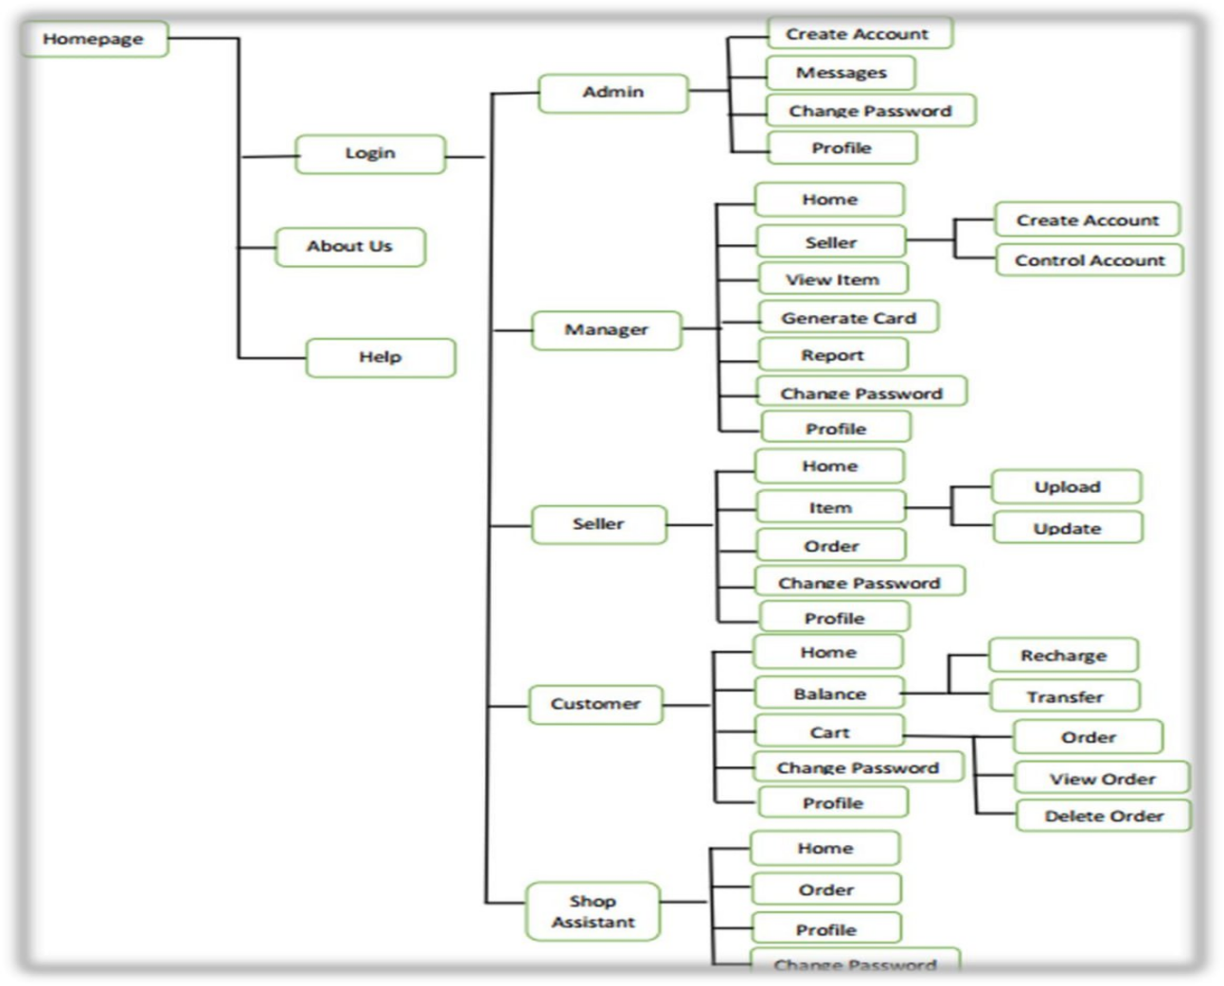  
 Figure 3.1 User Interface Prototype

## 3.6 Security and safety procedureUserAuthentication

User authentication ensures that only authorized individuals can access the system. This involves the use of secure login credentials (username and password), and to enhance security, multi-factor authentication (MFA) can be implemented. This prevents unauthorized access to accounts and sensitive data  
 Data Encryption  
Sensitive information such as passwords, payment details, and personal data is encrypted using secure communication protocols like HTTPS/SSL. This encryption ensures that data transmitted between the user’s browser and the system server remains private and protected from interception or tampering.  
Access Control  
Access control systems limit user access to specific parts of the platform based on their role. For example, customers can only access their profile and orders, while administrators have access to manage products, users, and reports. Role-based access ensures that unauthorized users cannot access or modify sensitive data.  
Secure Payment Gateway  
All financial transactions are processed through secure and certified payment gateways that ensure encryption and compliance with financial standards. Payment details, including credit card numbers, are securely handled and are never stored on the system, reducing the risk of data breaches.  
Input Validation  
To prevent security vulnerabilities like SQL injection, cross-site scripting (XSS), and cross-site request forgery (CSRF), the system performs strict validation of all user inputs. This ensures that only valid data is processed and helps prevent malicious code from being executed.  
Regular Data Backup  
The system regularly backs up all critical data, including user accounts, transaction records, and product information. This is crucial in case of data corruption, accidental deletion, or system failure, ensuring that the platform can be restored to a secure state without data loss.  
User Activity Monitoring  
The system monitors and logs user activity, tracking actions such as logins, purchases, and changes to user profiles. Monitoring helps detect suspicious or fraudulent behavior in real-time and provides an audit trail in case of security incidents.  
Firewall and Antivirus  
A firewall protects the system from unauthorized access by filtering incoming and outgoing network traffic based on predetermined security rules. Additionally, antivirus software is used to scan and remove malware, preventing malicious attacks and ensuring the safety of the platform.  
Session Management  
User sessions are securely managed to prevent session hijacking or unauthorized access. Sessions are timed out after periods of inactivity, and secure cookies are used to handle session IDs. This helps ensure that users are logged out automatically after a certain time, reducing the risk of session theft. Password Policy Enforcement  
A strong password policy is enforced to ensure that users create secure passwords. This includes requirements for minimum length, the use of uppercase and lowercase letters, numbers, and special characters. Users are also encouraged to update their passwords regularly to enhance security.   
Secure Admin Panel  
The administrator panel is secured with additional layers of protection, such as IP-based restrictions, multi-factor authentication (MFA), and secure login protocols. This ensures that only authorized personnel can access the backend system and make critical changes to the platform.  
 Data Privacy Compliance  
The system adheres to relevant data privacy laws, such as the General Data Protection Regulation (GDPR), to ensure that user data is collected, stored, and processed in compliance with privacy rights. Users have control over their data, with options to view, update, or delete their personal information as per legal requirements.

# 

# 

# CHAPTER FOUR

# SYSTEM MODELING

## 4.1 INTRODUCTION

This chapter focuses on modeling the proposed online electronics shopping website for Abenezar. System modeling provides a blueprint of the system's functionality, behavior, and structure through different Unified Modeling Language (UML) diagrams. These models help stakeholders understand system interactions, data flow, and object relationships, ensuring a shared understanding of system requirements before implementation

## 4.2 Actor identification

|  |  |
| --- | --- |
| **Actor** | **Description** |
| **Customer** | Browses products, registers/logs in, adds products to cart, places orders, and makes payments |
| **Admin** | Manages products, categories, customers, and views sales reports |
| **Delivery Staff** | Updates order delivery status. |
| **System** | Automatically sends notifications and confirmation emails. |
| **Manager** | Registers and manages employee accounts, generates business and sales reports, creates recharge cards, and oversees overall platform operations |

Table:4.1:Actor identification   
 4.3 USECASE IDENTIFICATION

|  |  |  |
| --- | --- | --- |
| Use Case ID | Use Case Name | Associated Actors |
| UC01 | User Registration | Customer |
| UC02 | Login | Customer,Admin,Delivery Staff |
| UC03 | Browse Products | Custome |
| UC04 | Add to Cart | Custome |
| UC05 | Place Order | Custome |
| UC06 | Make Payment | Customer |
| UC07 | Manage Products | Admin |
| UC08 | Manage Users | Admin |
| UC09 | View Reports | Admin |
| UC010 | Update Delivery Status | Delivery Staff |
| UC011 | Send Notifications | System |

Table:4.2:Customer Use Cases

|  |  |
| --- | --- |
| **Use Case Name** | **Description** |
| Register Account | Customer signs up with personal details. |
| Login | Authenticates with username/email and password. |
| Browse Products | Views products by category, price, or popularity. |
| Search Products | Searches products using keywords |
| View Product Details | Sees detailed information specs, price, reviews. |
| Add to Cart | Adds items to a virtual shopping cart |
| Update Cart | Changes quantity or removes items in the cart. |
| Place Order | Confirms items in the cart and places an order |
| Make Payment | Pays using selected payment method e.g., credit card, mobile money. |
| Track Order | Views current status of placed order (pending, shipped, delivered |
| Cancel Order | Cancels the order if not yet shipped. |
| View Order History | Views list of past orders with details. |
| Update Profile | Edits personal info like address or contact. |
| Logout | Ends session securely. |

Table:4.3:Customer Use Cases

|  |  |
| --- | --- |
| **Use Case Name** | **Description** |
| Login | Admin logs into the system |
| Manage Products | Adds, updates, or deletes products. |
| Manage Categories | Creates and edits product categories. |
| Manage Users | Views, edits, or blocks user accounts. |
| View Sales Reports | Sees revenue, orders, and user activity stats. |
| View Order List | Reviews all customer orders. |
| Manage Returns/Complaints | Handles customer service issues. |
| Logout | Logs out of the admin dashboard. |

Table 4.4.Admin Use Cases

|  |  |
| --- | --- |
| Use Case Name | Description |
| Login | Delivery staff logs into the system |
| View Assigned Order | Sees orders assigned to them for delivery. |
| Update Delivery Status | Marks orders as "in transit", "delivered" |
| Logout | Logs out after updating deliveries. |

Table 4.5: Delivery Staff Use Cases

|  |  |
| --- | --- |
| Use Case Name | Description |
| Send Confirmation Emails | Sends order/payment confirmation to users. |
| Send Delivery Notification | Notifies customers when order is shipped or delivered. |
| Alert Admin for Low Stoc | Sends alerts when product inventory is low. |

##### Table 4.6 System Automated Use Cases

## 4.4. System use case diagram

A Use Case Diagram is a behavioral UML diagram used to represent the functional requirements of a system. It visually describes the interactions between actors (users or external systems) and the system itself to achieve a goal.

Purpose:

To identify the key functionalities the system must provide.

To show who interacts with the system (e.g., customers, admins).

To provide a high-level overview of the system behavior.

To support requirement gathering and system design.

Actors in Online Shopping System for Harana Electronics:

Customer – End-user who browses, purchases, and reviews products.

Admin – Manages product listings, orders, and users.

Payment Gateway – External service that processes online payments.

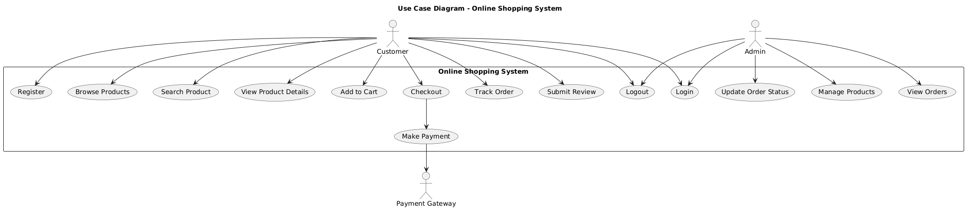

### Figures 4.4.1:use case diagram online shopping

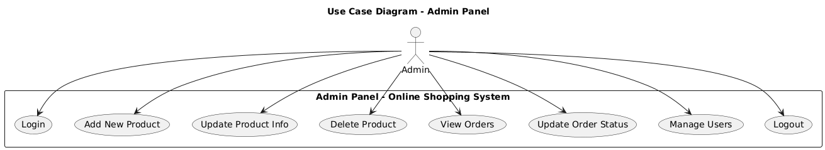

Figures 4.4.2:use case diagram Admin panel

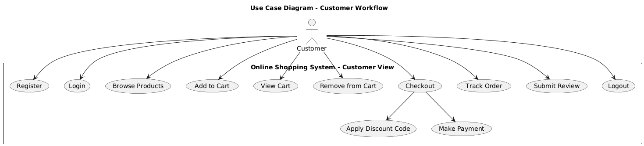

Figures 4.4.3:use case diagram customer workflow

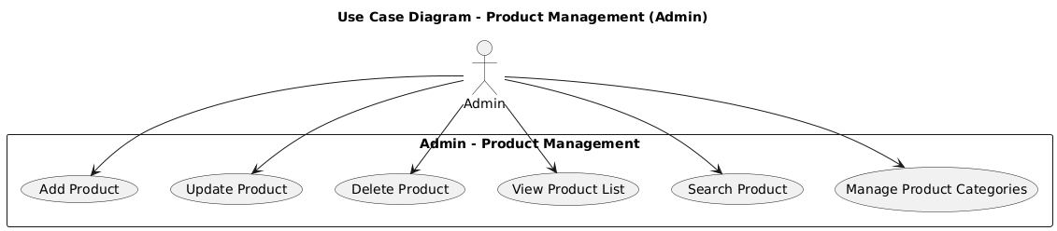

Figures 4.4.4:use case diagram product management (admin)

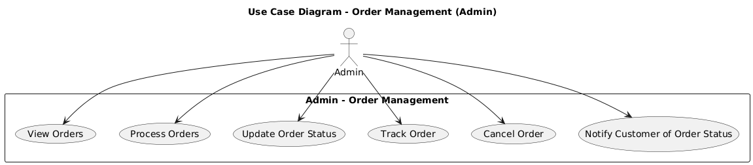

Figures 4.4.5:use case diagram order management

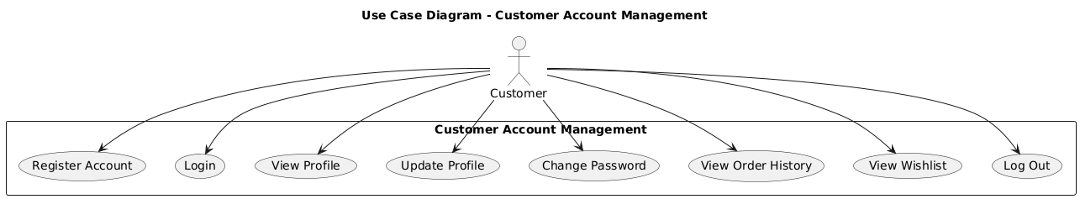

### Figures4.4.6:use case diagram customer acount

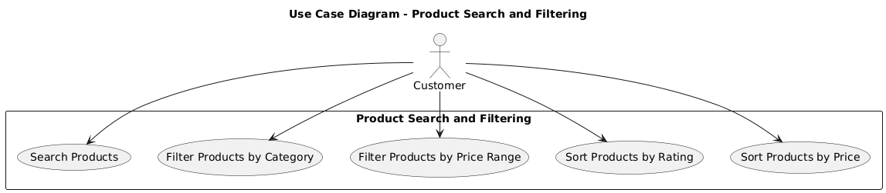

Figures4.4.7:use case diagram product search & filtering

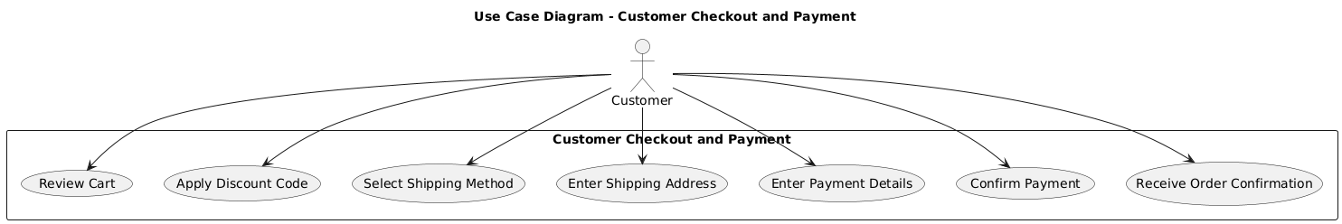

Figures4.4.8:use case diagram customer checkout & payment

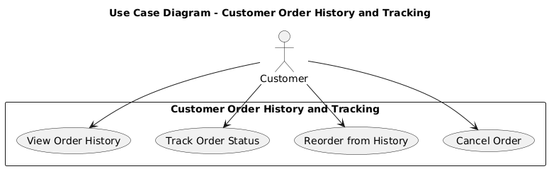

Figures 4.4.9:use case diagram customer order History

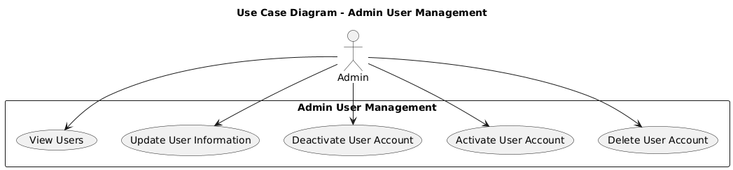

### Figures 4.4.10:use case diagram Admin user

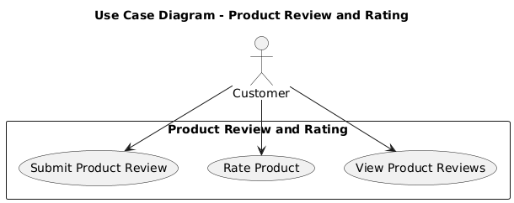

### 

### Figures4.4.11:use case diagram product Review

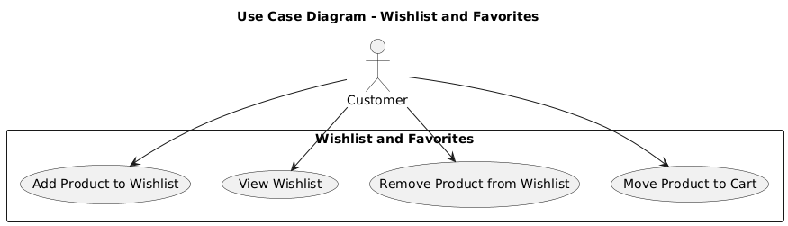

Figures4.4.12:use case diagram wishlist

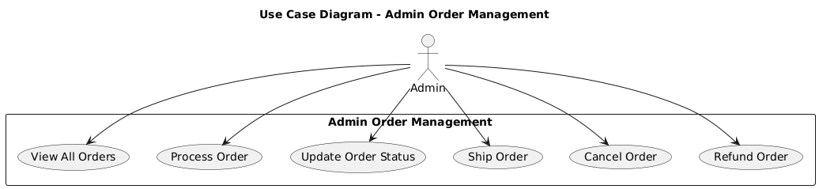

Figures 4.4.13:Figures:use case diagram Admin order

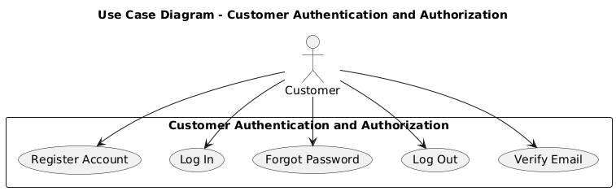

Figures 4.4.14:use case diagram customer&Authentication

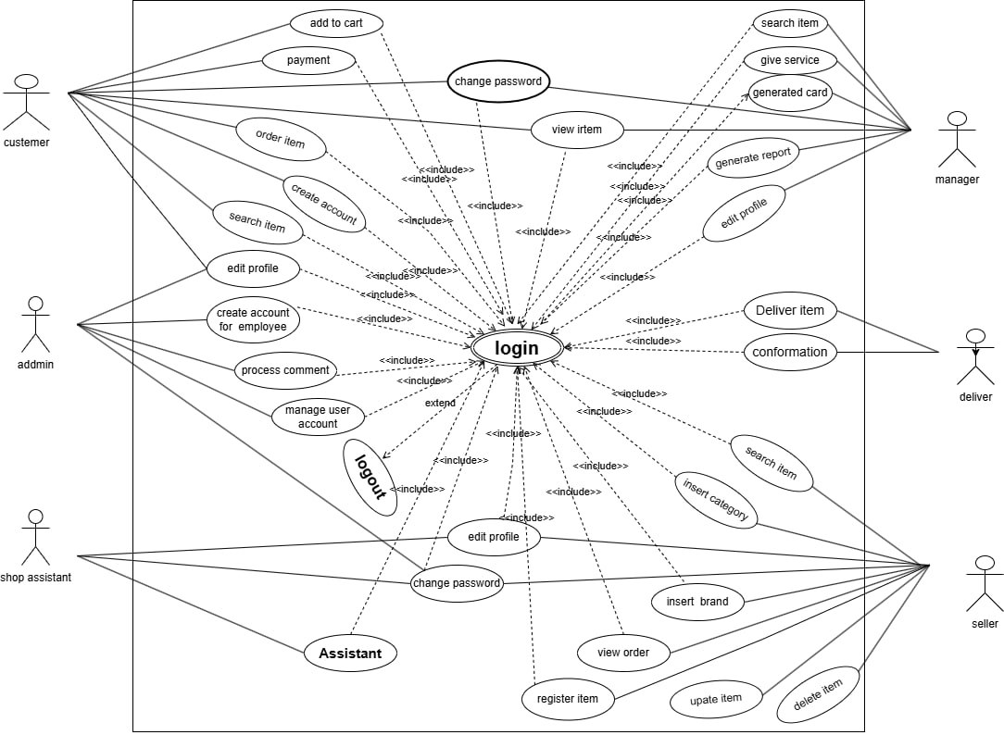

### Figure 4.4.15: Use case diagram

# 4.4.1 Use case documentation

|  |  |  |
| --- | --- | --- |
| Use-case name | LOGIN | |
| Use-case number | **UC01** | |
| Description | use case to ensure security in system usage | |
| Actor | user: (customer, manager, seller, shop assistant and Admin) | |
| Pre-condition | User must have username and password | |
| Post-condition | User gets access to the system according to their predefined system privilege and finally he/she logout of the page | |
| **Basic course of actions** | User action | **System Response** |
| - User activates the system.  -. User fills his or her user ID and password and click login button.  -. User authenticated and gets access to the system. | -System displays login interfaces and prompts the user for the user ID and password.  -System verifies user ID and Password.  - System displays its main window. 7-.use case ends. |
| **Alternative course of action** | -if user enters wrong user ID and or password   * 1. System displays an incorrect user ID and password message.   2. Go to step 2   3. The use case resumes at step 3 of flow of events.   -Use case ends. | |

##### 

##### 

##### Table 4.4.1: use case description for login

|  |  |  |
| --- | --- | --- |
| Use-case number | UC02 | |
| Use-case name | **Change Password** | |
| Description | Use case to allow users to change their password. | |
| Actor | Seller, Admin, Customer, Assistant and Manager | |
| Pre-condition | UC01 | |
| Post-condition | password is changed successfully | |
| **Basic course of actions** | **User action** | **System Response** |
| -User clicks “change password” link.  - User fills the form  and clickson“change”  button. | -System displays change password interface and form.  -System controller verifies the form.  -System displays successfully changed message.  -Use case Ends. |
| **Alternativecourse of**  **action** | If form fill information is incorrect  System display error message and returns back to step 2 | |

##### Table 4.4.2: Use case description for change password

|  |  |  |
| --- | --- | --- |
| **Use-case number** | **UC03** | |
| **Use-case name** | Search Item | |
| **Description** | Use case to retrieve item from data base. | |
| **Actor** | Guest and Customer | |
| **Pre-condition** | User Must visit the system | |
| **Post-condition** | The item is successfully retrieved. | |
| **Basic course of actions** | **User action** | **System Response** |
| - Users enters the name of the item andclick on  “search” button. | -System checks from database.  -System displays the item from database.  -Use case ends |
| **Alternative courseof action** | If the item is not found in database the system displays not found message and returns to step 1 | |

##### Table 4.4.3: Use case description for search item

|  |  |  |
| --- | --- | --- |
| Use-case number | **UC04** | |
| Use-case name | **view Item** | |
| Description | This use case allows Manager and seller to view or display all items with their detail description about the item. | |
| Actor | manager and Seller | |
| Pre-condition | UC01 | |
| Post-condition | view all item with full information | |
| Basic course of actions | **User action** | **System Response** |
| -Manager and seller clicks the item button. | -System displays item information from the data base.   1. Use case ends. |
| **Alternative course of action** | If the item is not found in database the system displays not found message and returns to step 1 | |

##### Table 4.4.4: Use case description for view item

|  |  |  |
| --- | --- | --- |
| Use case number | UC-05 | |
| Use case Name | **Order Item** | |
| Actor: | Customer | |
| Description | Customers’ order the item, when he/she wants to buy the item. | |
| Precondition | * UC04 * Customer selects the item. * The customer must be register. | |
| Post condition | When items are ordered total amount of items must be decreased. | |
| **Basic course of action** | User action | System response |
| - Customer visit the system.  -Customer enter item name and clicks on search button.  -Customer select the item.  -Customer select quantity of item and click “add to cart “button  -Customer clicks on cart link  -Customer clicks on checkout button.  -customer fills form and click on order button  -customer prints receipt | -System displays search form.  -System verifies the input from database.  -System retrieves search result  -Sstem displays quantity of item, price and add to cart button.  -System adds the item on cart.  -System displays list of item on cart  -system displays personal information form  -system controller checks form and add information in database  -Systemcreates receipt with confirmation code  -use case ends |
| **Alternative course of action** | If the item is not found the system state is unchanged.  If there is no enough balance system display “not enough” message. | |

##### Table 4.4.5: Use case description for order item

|  |  |  |
| --- | --- | --- |
| Use-case Number | UC-06 | |
| Use-case Name | **View Order** | |
| Actor | Seller and shop assistant | |
| Description | Use case allow Seller and shop assistant to view list of ordered items. | |
| Pre-condition | UC-01 | |
| Post-condition | Seller and shop assistant views customers order. | |
| **Basic course of Action** | User Action | System Response |
| -Seller and shop assistant initiates to view orders on main menu.  . Seller and shop assistant clicks the  order link. | -System displays order link.  - System sends the requested order to DB and display orders on order UI.  -use case ends |

##### Table 4.4.6: Use case description for view order

|  |  |  |
| --- | --- | --- |
| Use case number | UCO7 | |
| Use case Name | **update Item** | |
| Actor: | Use case to edit or change the existing item information. | |
| Related use case | Seller | |
| Description | Item must exist in database | |
| Precondition | System updates the item information. | |
| Post condition | update Item | |
| **Basic course of action** | User action | System response |
| Seller enters main menu  Seller select item and clicks on update button.  Seller fills item information. | System displays list of items  System displays update item user interface.  System controller verifies the form  System successfully updates information.  Use case Ends. |
| **Alternative course of**  **action** | 1. If item is not found returns back to basic course of action 2 to update item. | |

##### Table 4.4.7: Use case description for update item

|  |  |  |
| --- | --- | --- |
| Use case number | UCO8 | |
| Use case Name | **Register Item** | |
| Actor: | Seller | |
| Description | Use case to insert items into item table. | |
| Precondition | UC01 | |
| Post condition | Items are registered to the data base. | |
| **Basic course of action** | User action | System response |
| Seller enters into main menu and clicks on register item button.  Seller fills information about the item and clicks on register button. | System displays item registration form.  System controller verifies a form store into database.   1. System displays message. 2. Use case Ends. |
| **Alternative course of action** | If item is not correctly filled returns back to basic course of action 2 to  register item. | |

##### 

##### Table 4.4.8 :Use case documentation for register item

|  |  |  |
| --- | --- | --- |
| Use-case Number | UC-09 | |
| Use-case Name | **Register Employee** | |
| Actor | Manager | |
| Description | Use case to register employee. | |
| Pre-condition | UC-01 | |
| Post-condition | The seller is successfully registered. | |
| **Basic course of Action** | User Action | System Response |
| The manager enters to main menu and clicks on register employee button.  The manager fills the form and clicks on register button. | System displays registration form.  The system controller verifies the form.  The system stores into database.  System displays message.  Use case Ends. |

##### Table 4.4.9 Us case documentation for register employe

|  |  |  |
| --- | --- | --- |
| Use-case Number | UC-10 | |
| Use-case Name | **Manage employee account** | |
| Actor | Manager | |
| Description | Use case to control employee account. | |
| Pre-condition | UC-01 | |
| Post-condition | Manager control seller account. | |
| **Basic course of Action** | User Action | System Response |
| The manager enters into main menu and clicks on manage seller link.  The manager enable or disable seller account. | System displays list of seller and search form.  Use case Ends. |

##### Table 4 .4.10:Use case documentation for manage seller account

|  |  |  |
| --- | --- | --- |
| Use-case Number | UC-11 | |
| Use-case Name | **Charge balance** | |
| Actor | Customer, | |
| Description | Use case to allow customer to insert money into their account. | |
| Pre-condition | Customer must buy card from shop. | |
| Post-condition | The amount is successfully charged and added to customers’ account | |
| **Basic course of Action** | User action | System Response |
| Customer clicks on recharge balance.  Customer enters hidden number and clicks recharge button. | System displays charging interface  System adds balance to customers account and send message.  Use case Ends. |
| **Alternate course of Action** | If the card number is not correct, system displays error message. | |

##### Table 4.4.11: Use case documentation for charge balance

|  |  |  |
| --- | --- | --- |
| Use-case Number | UC-12 | |
| Use-case Name | **Transfer balance** | |
| Actor | Customer | |
| Description | Use case to allow customer to transfer balance to another customer. | |
| Pre-condition | Customer must have enough balance in his/her account. | |
| Post-condition | The balance is transferred successfully. | |
| **Basic course of Action** | User action | System Response |
| Customer clicks on recharge balance button.  Customer clicks on transfer balance button.  Customer fills the email of the customer.  Customer enters amount of money to be transferred and clicks on transfer button.  Customer clicks on “yes” option. | System displays transfer balance link.  System requests customers email to transfer balance.  System requests amount of money to be transferred.  System displays “are you sure to transfer” message with “yes/no” option.  System displays message.  . Use case Ends. |
| **Alternate course of Action** | If customer clicks on “no” option system returns back to home.  If there is no enough balance from customer account, system displays “you have not enough balance please recharge” message. | |

##### 

##### Table 4.4.12: Use case documentation for transfer balance

|  |  |  |
| --- | --- | --- |
| Use-case Number | UC-13 | |
| Use-case Name | **Generate Report** | |
| Actor | Manager | |
| Description | Use case to allow manager to generate a report about the item information. | |
| Pre-condition | UC-01 | |
| Post-condition | Generate monthly report. | |
| **Basic course of Action** | User action | System Response |
| 1. Manager enter to the main menu and clicks on generate report button.  Manager select criteria and fills the selected criteria. | System request criteria to generate report.  System generates report.  Use case Ends. |
| **Alternate course of Action** | If the selection information is empty or not found go to 3. | |

##### Table 4.4.14 Use case documentation for generate report

|  |  |  |
| --- | --- | --- |
| Use-case Number | UC-14 | |
| Use-case Name | **Logout** | |
| Actor | Admin, Seller, Customer, Manager and Shop assistant | |
| Description | Use case to sign out from the system. | |
| Pre-condition | UC-01 | |
| Post-condition | User logouts from the system | |
| **Basic course of Action** | User Action | System Response |
| User clicks on logout button. | System responds the requested action.  Use case Ends. |

##### Table 4.4.14: Use case documentation for logout

|  |  |  |
| --- | --- | --- |
| Use-case Number | UC-15 | |
| Use-case Name | **Generate card** | |
| Actor | Manager | |
| Description | Use case to allow manager to prepare card number. | |
| Pre-condition | **UC01** | |
| Post-condition | Card number is successfully generated | |
| **Basic course of Action** | User Action | System Response |
| -Manager click on “generate card” link  -Manager enter amount of card | . system request amount of each generated card  -system save generate card in database   1. system display generated card 2. use case ends |

##### Table 4.4.15: Use case documentation for generate card

|  |  |  |
| --- | --- | --- |
| Use-case Number | UC-16 | |
| Use-case Name | **deliver item** | |
| Actor | Shop assistant | |
| Description | Use case to give Ordered item for customer | |
| Pre-condition | Item must be ordered | |
| Post-condition | Customer received the item from shop assistant | |
| **Basic course of Action** | User Action | System Response |
| -shop assistant click on “Delivered” button  -shop assistant enter order id | -system request order id  . system checks order id  . use case ends |
| **Alternative course of action** | If the order id is not correct  System displays “please enter the correct order id ”  After three times trial System returns back to shop assistant homepage. | |

##### Table 4.4.16 Use case documentation for deliver item

|  |  |  |
| --- | --- | --- |
| Use-case Number | UC-17 | |
| Use-case Name | **Return item** | |
| Actor | Customer | |
| Description | Use case to return ordered items if it has a problem. | |
| Pre-condition | Customer must have enough reason. | |
| Post-condition | Item is returned or changed by other item. | |
| **Basic course of Action** | User Action | System Response |
| . Customer clicks return link.  . Customer fill form and clicks on submit button.  . use case ends | . System displays return form. |

##### Table 4.4.17 Use case documentation for return item

|  |  |  |
| --- | --- | --- |
| Use-case Number | UC-18 | |
| Use-case Name | Payment | |
| Actor | Customer | |
| Description | Use case to pay money for ordered items. | |
| Pre-condition | Customer must have enough balance | |
| Post-condition | Customer received the item from shop assistant | |
| Basic course of Action | User Action | System Response |
| . Customer clicks on cart link  . Customer clicks on checkout button.  . customer fills form and click on order button | . System displays list of item on cart and total price.  . system displays personal information form  . System checks balance of customer and store information in database.  . use case ends |
| Alternative course of action | 1. If there is enough balance in customer account, system displays message to recharge balance. | |

##### Table 4.4.18: Use case documentation for payment

## 4.5 Dynamic Modelling

### 4.5.1.Sequence Diagram

A sequence diagram is a UML interaction diagram. It represents the chronology of the passing of messages between system objects and actors. It used to illustrate a possible scenario of a use case, the execution of an operation, or simply an interaction scenario between classes of the system.

To use one or more sequence diagrams to pass a use case or to identify all the possibilities of a complex behavior. A sequence diagrams conveys the same kind of information it concentrates on the chronology of messages passing between the objects in place of their structure.

A sequence diagram shows actors, objects (instances of classes) and the messages sent between them. By default, Power Designer provides an "interaction frame", which surrounds the objects in the diagram. Messages can originate from or be sent to any point on the interaction frame, which acts as the exterior of the system being modeled, and these gates can be used in place of actor objects.  
  
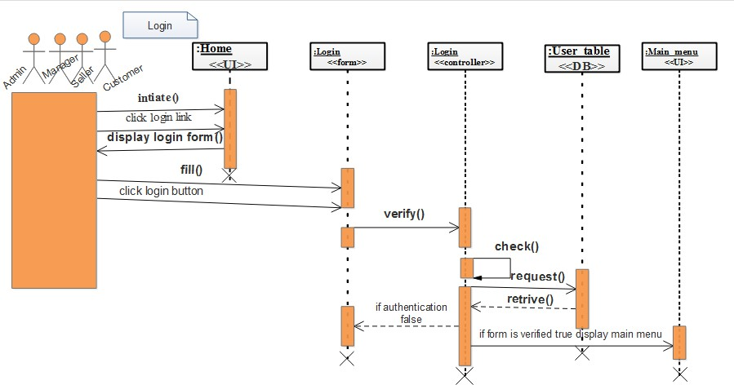

### Figure 4.5.1.1: sequence diagram for login

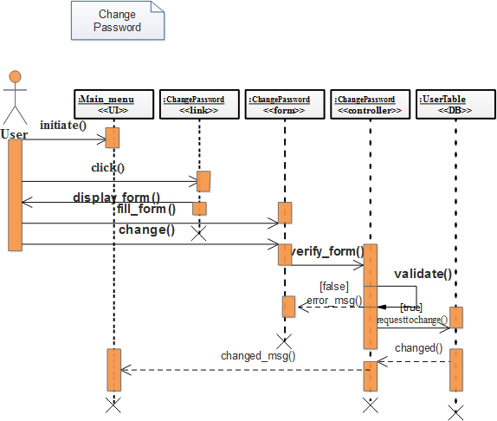

### Figure 4.5.1.2: sequence diagram for change password

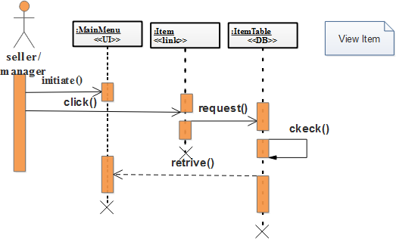

### Figure 4.5.1.3: sequence diagram for view item

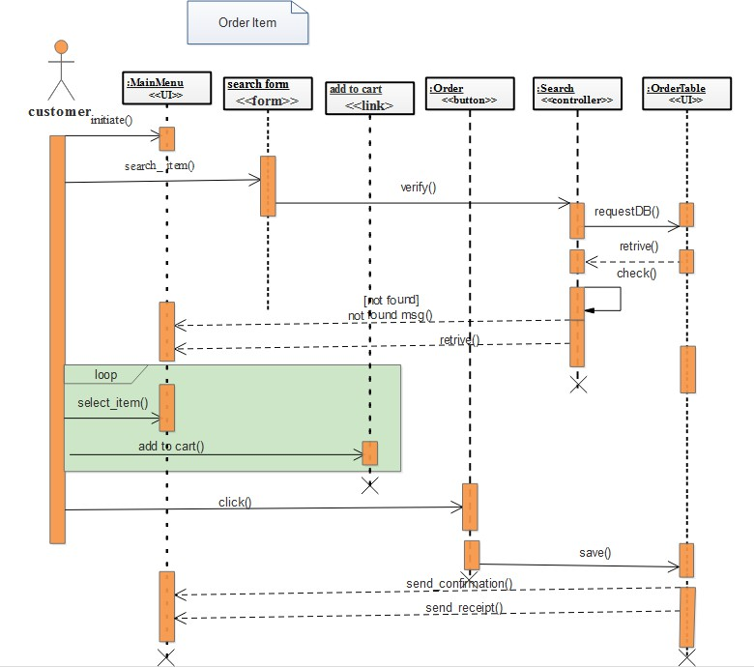

### Figure 4.5.1.4: sequence diagram for order item

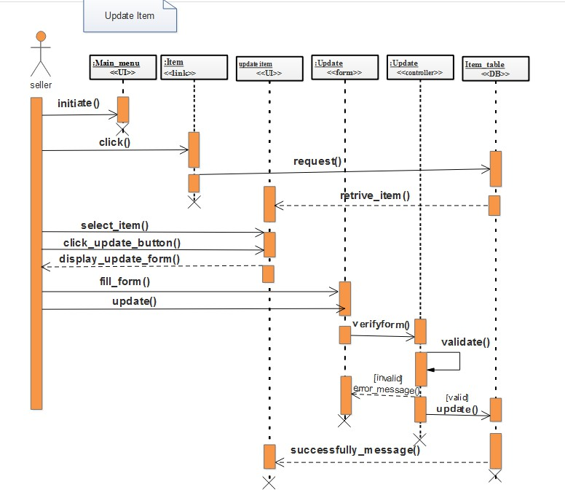

### Figure 4.5.1.5: sequence diagram for update item

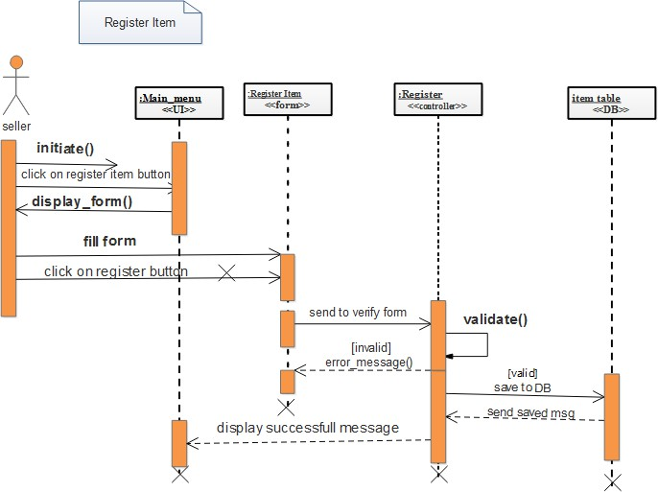

### Figure 4.5.1.6: sequence diagram for register item

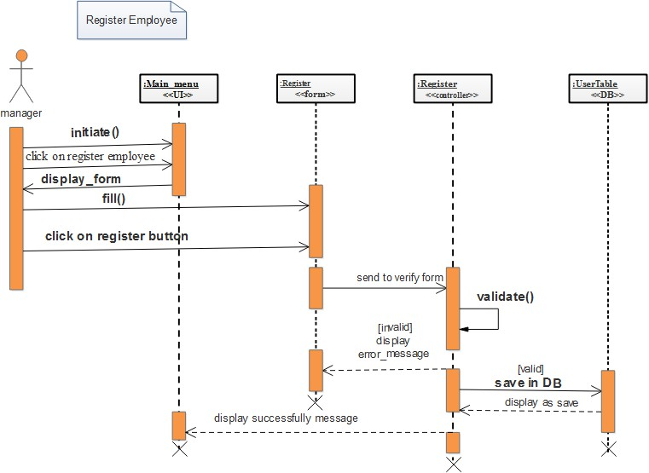

### Figure 4.5.1.7: sequence diagram for register employee

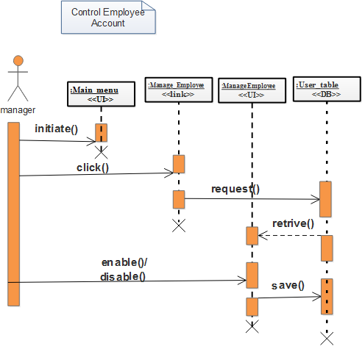

### Figure 4.5.1.8: sequence diagram for manage employee account

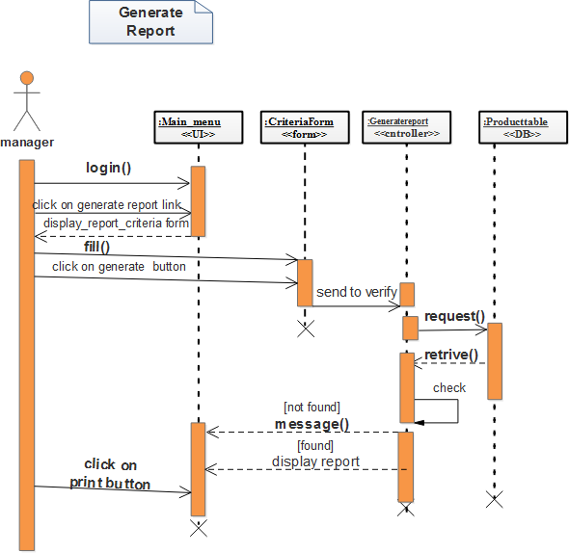

### 

### Figure 4.5.1.9: sequence diagram for generate report

# 

### 4.5.2. Collaboration Diagram

A Collaboration Diagram (also called a Communication Diagram) is a type of interaction diagram in UML that shows how objects interact with one another and how messages are passed between them in the context of completing a specific task or use case. It emphasizes the structural organization of the system.In the case of the Online Shopping System for Abenezar Electronics, a collaboration diagram models the interaction between objects involved in a customer placing an order.

### Purpose of the Collaboration Diagram

To depict how different objects (actors and system components) collaborate to complete a task.

To show the sequence and structure of message exchanges.

To support the development of detailed design specifications

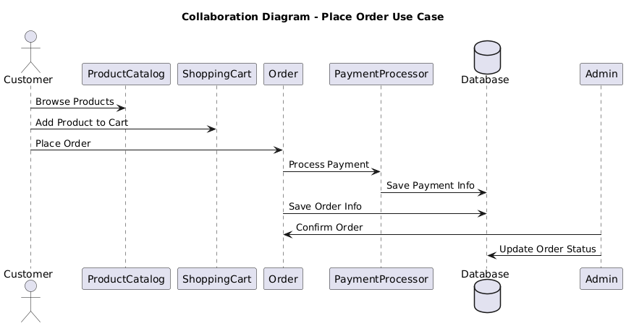

### Figures 4.5.2.1: collaboration diagram place order

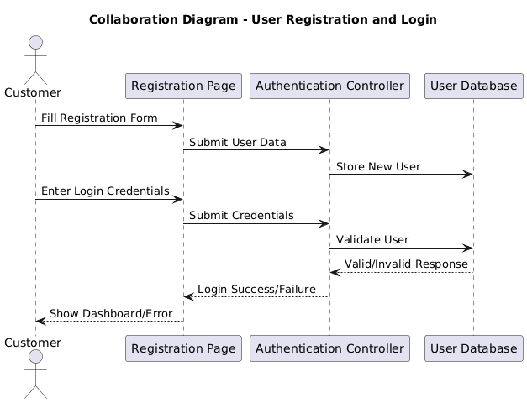

Figures 4.5.2.2: collaboration diagram user regstitraction

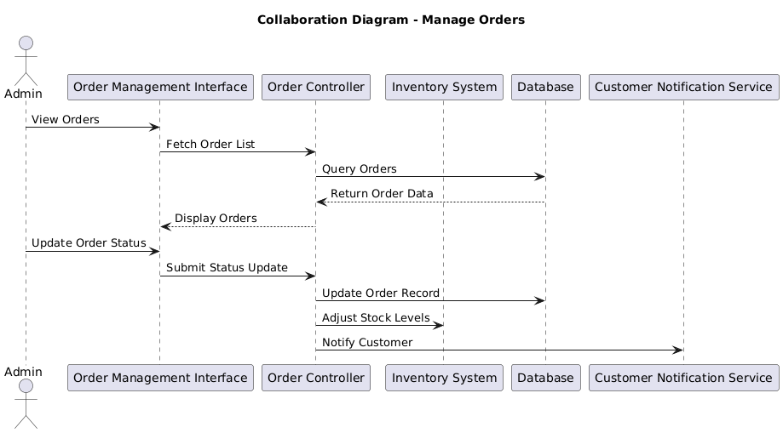

### Figures 4.5.2.3: collaboration diagram manager orders

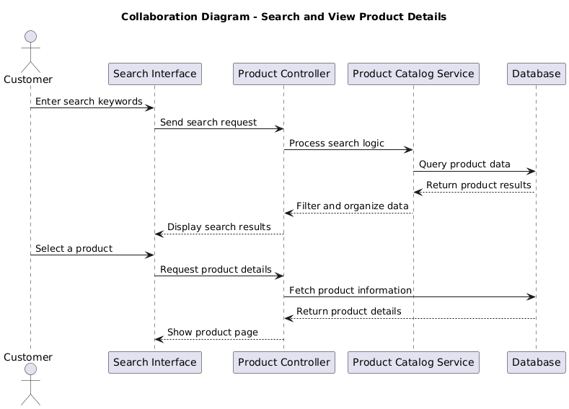

#### **Figures 4.5.2.4: collaboration diagram customer search & view**

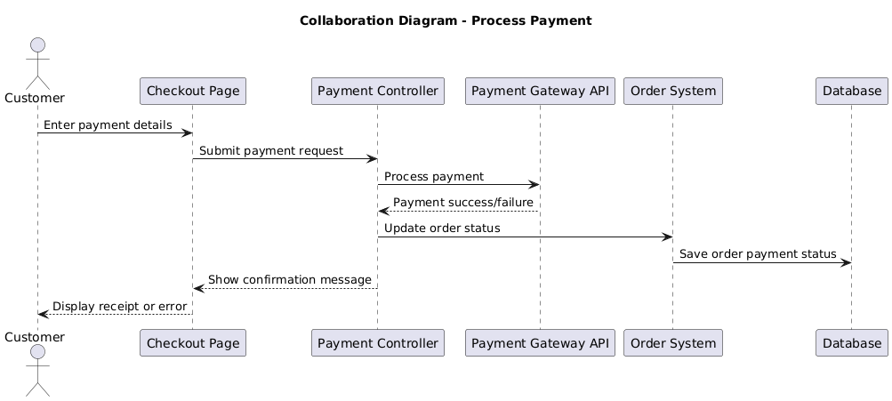  
  
 Figures 4.5.2.5: collaboration diagram proces payment

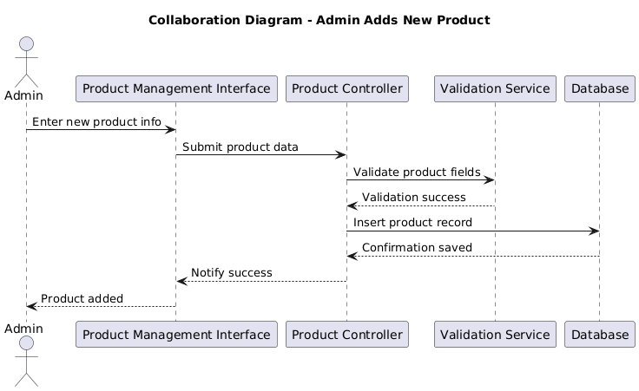   
 Figures 4.5.2.6: collaboration diagram Admin adds

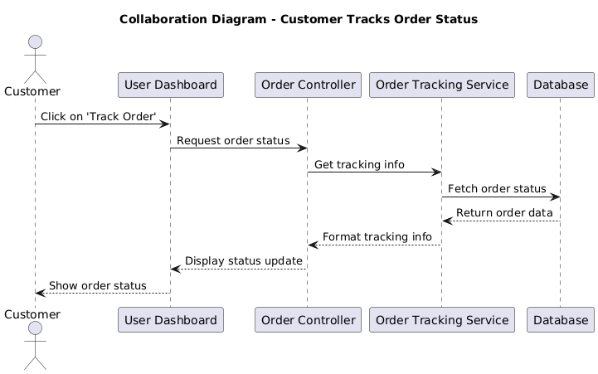

### 

### Figures 4.5.2.7: collaboration diagram customer tracks order

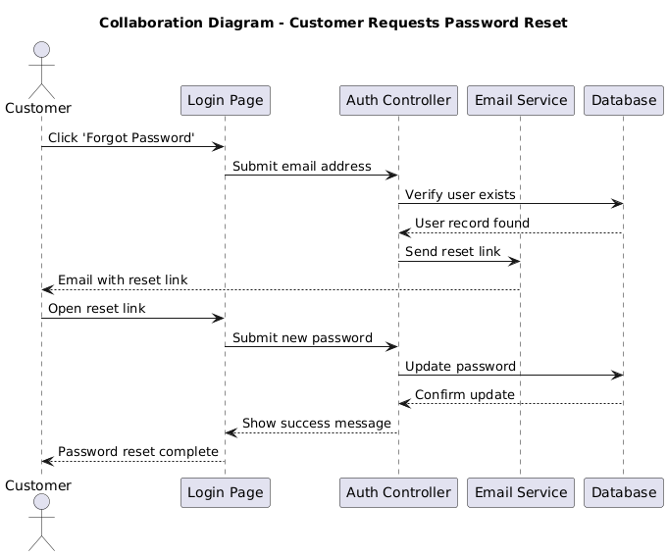

Figures 4.5.2.8: collaboration diagram customer request

### 4.5.3. Activity Diagram

An activity diagram illustrates the dynamic nature of a system by modeling the flow of control from activity to activity. An activity represents an operation on some class in the system that results in a change in the state of the system. Typically, activity diagrams are used to model workflow or business processes and internal operation. Because an activity diagram is a special kind of state chart diagram, it uses some of the same modeling conventions. Activity diagrams are mainly used as a flow chart consists of activities performed by the system. But activity diagram are not exactly a flow chart as they have some additional capabilities

.

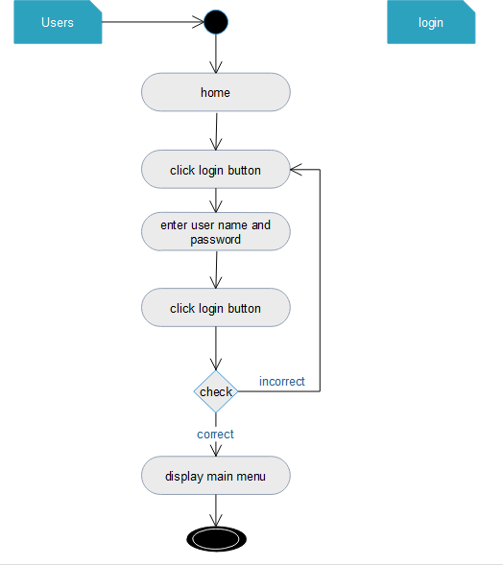  
  
 Figures 4.5.3.1 activity diagram for login

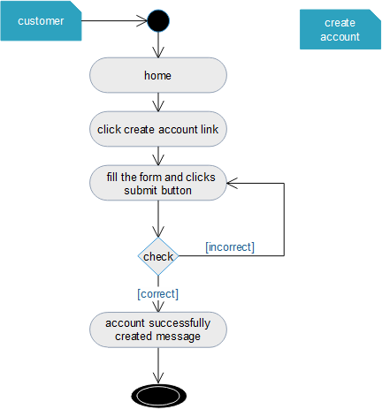

### Figures 4.5.3.2 activity diagram for create account

### Figures 4.5.3.3 activity diagram for change password

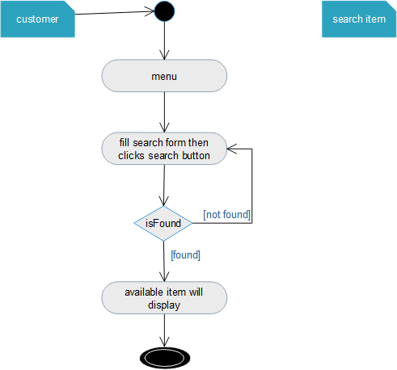

### Figures 4.5.3.4 activity diagram for search item

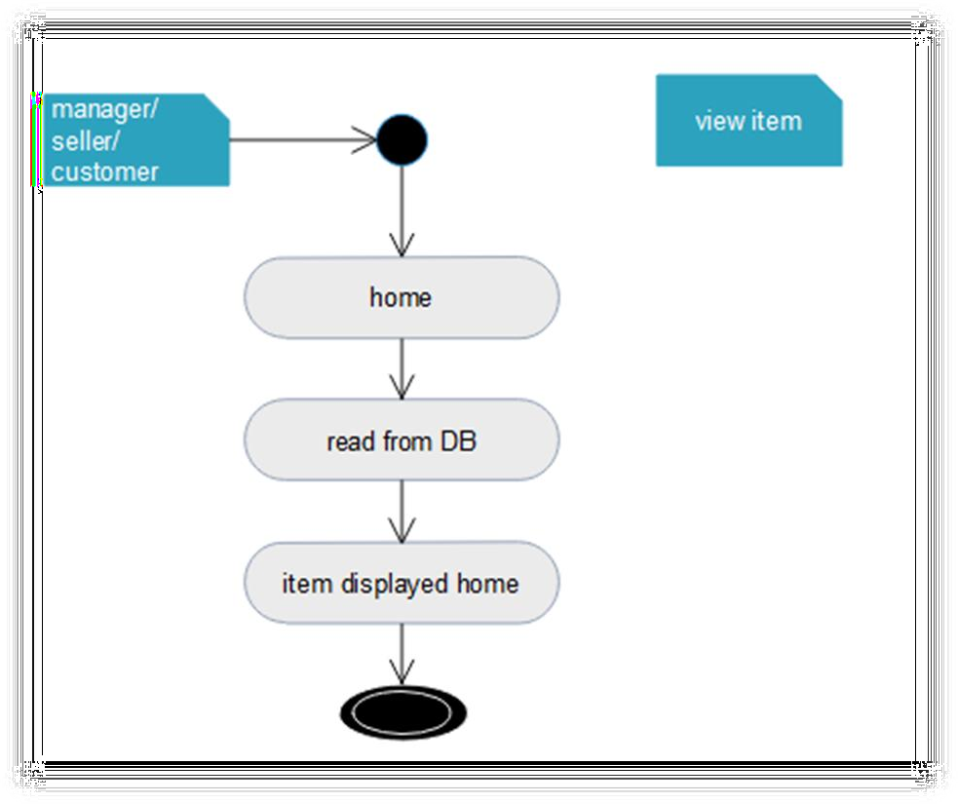

Figure 4.5.3.5 activity diagram for view item

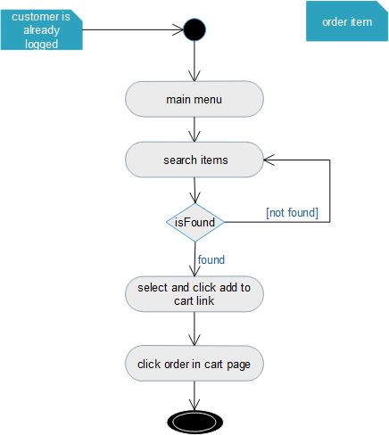

Figure 4. 5.3.6 activity diagram for order item

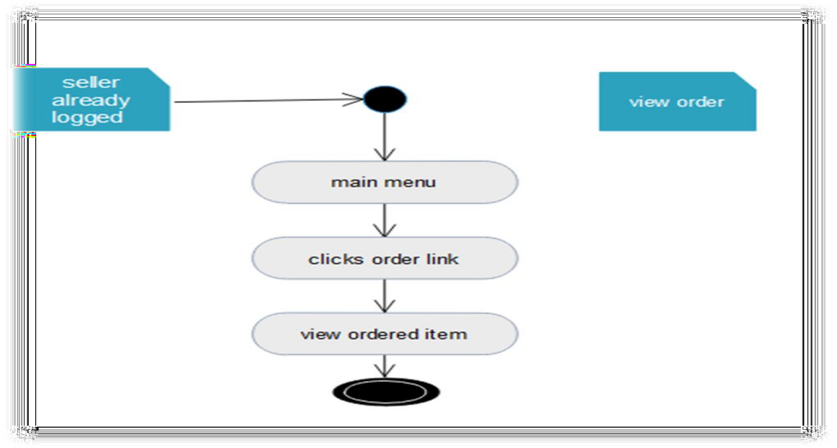

Figure 4.5.3.7 activity diagram for view order

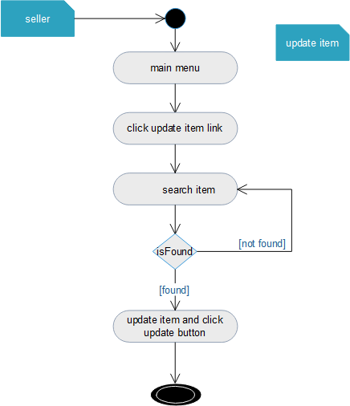

Figure 4.5.3.8 activity diagram for update item

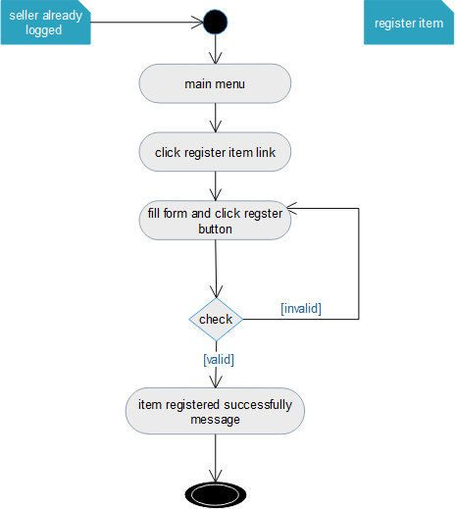

Figures 4.5.3.9 activity diagram for register item

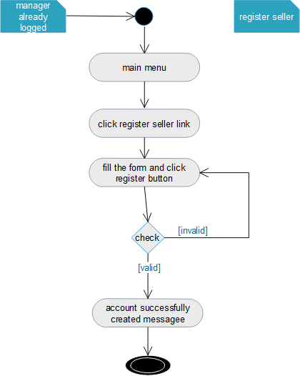

Figures 4.5.3.10 activity diagram for register seller

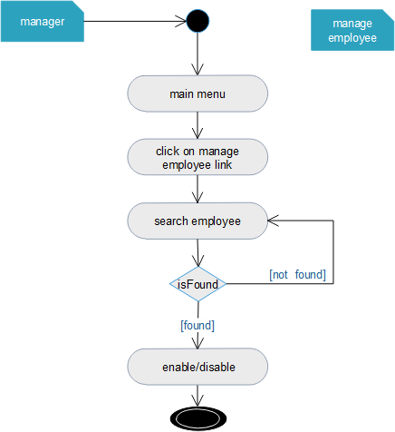

Figures 4. 5.3.11 activity diagram for manage employee account

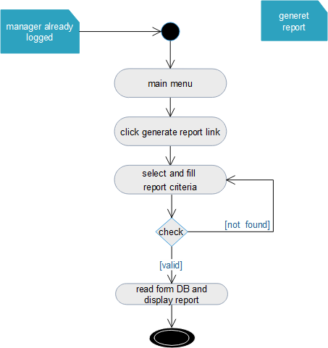

Figures 4.5.3.12 activity diagram for generate report  
  
 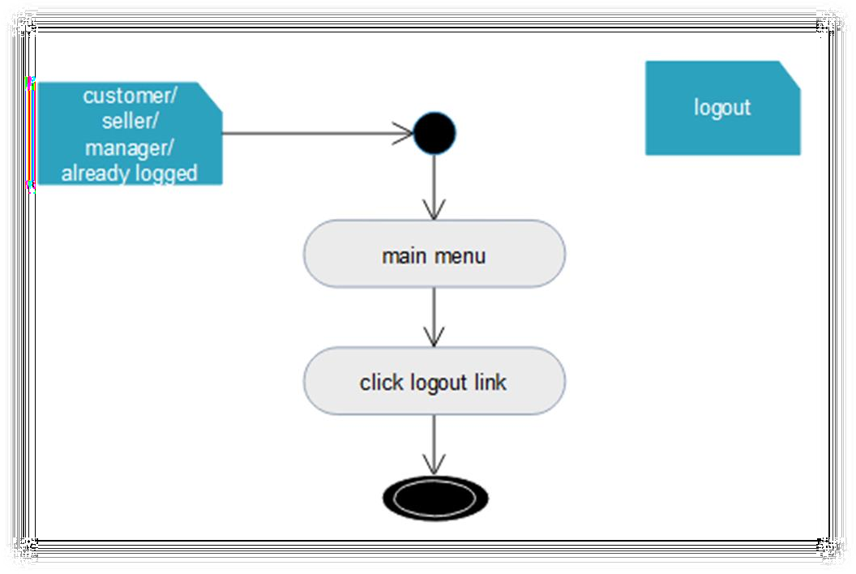   
  
 Figures 4.5.3.13 activity diagram for logout

### 4.5.4 State Chart Diagram

State Chart Diagram (also known as a State Machine Diagram) describes the dynamic behavior of an object in response to external stimuli by showing its possible states, transitions, and events. It is especially useful for modeling the lifecycle of entities, such as an order in an e-commerce system.

In the context of the Online Shopping System for Abenezar Electronics, the state chart diagram is used to model the lifecycle of a customer order, from creation to completion or cancellation.

### Purpose of the State Chart Diagram

To define the different states an order can be in.

To show how the order transitions from one state to another.

To model how the system reacts to user actions (e.g., place order, cancel) and system events (e.g., confirm, ship, deliver

### Benefits of Using State Chart Diagram

Provides a clear visualization of the object's behavior over time.

Helps in designing and debugging the order processing logic.

Ensures that business rules are followed for valid transitions.

Enhances system reliability and maintainability.

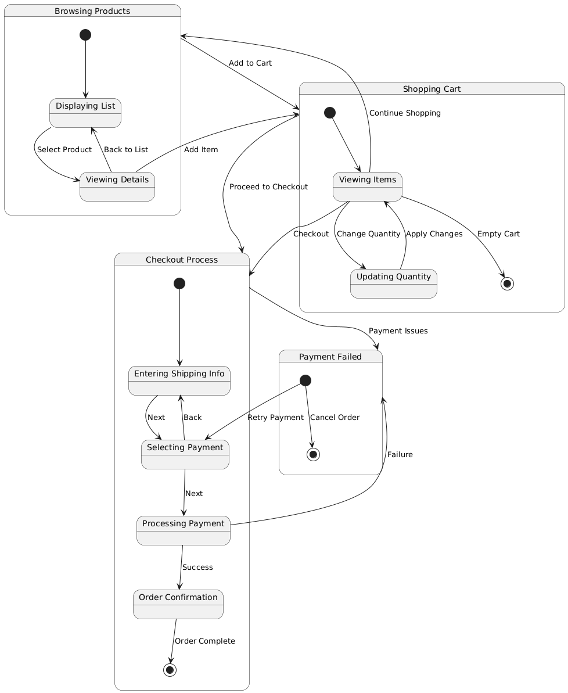

Figures 4.5.4.1 State Chart Diagram

## 4.6 Object modelling/static/conceptual modelling

An Object Diagram is a snapshot of instances of classes at a specific moment in time. It shows how objects in a system interact with each other based on real data values and functional relationships. Unlike a class diagram, which shows abstract design-level structure, an object diagram reflects a runtime example of a system's structure.

In the context of the “Online Shopping System for Abenezar Electronics”, the object diagram illustrates actual instances of key classes such as User, Product, Cart, Order, and Payment, along with their current attribute values and links. It is useful for understanding the dynamic behavior of the system during operations like browsing products, adding items to a cart, placing an order, and making a payment

### 4.6.1 Class Diagram

A class diagram is a type of static structure diagram that shows the system's classes, their attributes, methods, and the relationships among the classes. Below is a conceptual class diagram for the Online Shopping System for Abenezar Electronics.

User

Attributes: userId, name, email, password, role

Methods: login(), logout(), register()

Product

Attributes: productId, name, description, price, stockQuantity, category

Methods: addProduct(), updateProduct(), deleteProduct(), viewProduct(

Cart

Attributes: cartId, userId, items[]

Methods: addItem(), removeItem(), updateItem(), viewCart()

Order

Attributes: orderId, userId, orderDate, totalAmount, status

Methods: placeOrder(), cancelOrder(), viewOrder()

Payment

Attributes: paymentId, orderId, amount, paymentDate, paymentMethod, status

Methods: makePayment(), confirmPayment()

Admin

Attributes: adminId, name, email, password

Methods: manageUsers(), manageProducts(), viewReports()

Category

Attributes: categoryId, categoryName

Methods: addCategory(), updateCategory(), deleteCategory(

##### Relationships

A User can have many Orders.  
A User has one Cart.  
An Order is associated with one or more Products.  
A Cart contains multiple Products.  
An Order has one Payment.  
A Product belongs to one Category.

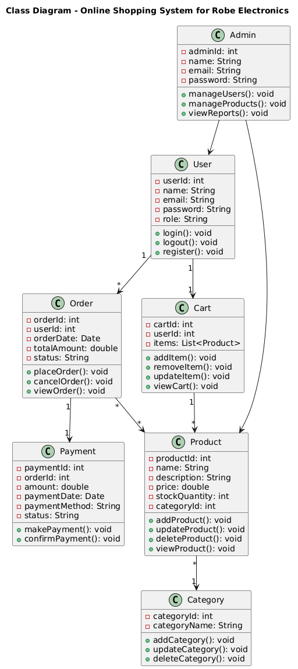 Figures.4.6.1 Object diagram

# CHAPTER FIVE

# SYSTEM DESIGN

## 5.1 INTRODUCTION

The purpose of design is to determine how the system is going to build and to obtain the information needed to drive the actual implementation of the system. It focuses on understanding the model how the software will be built. System design is the detail investigation of system elements from logical view.

It is designed to simplify functions of the manual system and it is capable of doing large amount of works in short period of time with more accuracy and reliability. Generally this project design describes how the project is designed, what tasks done under this project and different modules and their way of functioning.

## 5.2 Architectural Design

Architecture design is the process of defining a structured solution that meets all of the technical and operational requirements, while optimizing common quality attributes such as performance, security, and manageability. It involves a series of decisions based on a wide range of factors, and each of these decisions can have considerable impact on the quality, performance, maintainability, and overall success of the application.

Architecture design encompasses the set of significant decisions about the organization of a software system including the selection of the structural elements and their interfaces by which the system is composed; behavior as specified in collaboration among those elements; composition of these structural and behavioral elements into larger subsystems; and an architectural style that guides this organization

### 5.2.1 Component modeling

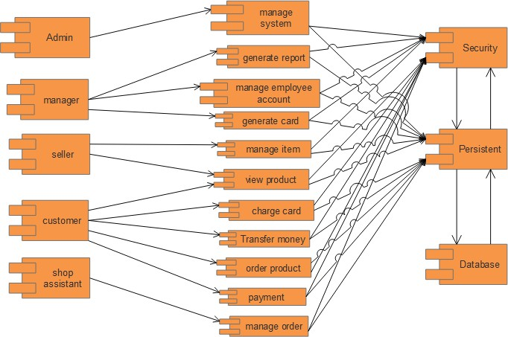In this Diagram components of the system will be wired showing that there is relation among components, management of the system, database and operations performed on databases such security issue. The diagram shows which component or objects will be accessed by whom and what type of security infrastructures are used. The diagram is simulated below  
  
   
 Figure 5.2.1: Component diagram

### 

### 5.2.2 Deployment Modeling

Deployment modeling shows how software components are physically distributed across hardware environments and how they interact with each other during system execution. It helps to visualize the deployment architecture and ensures proper allocation of system components to various nodes (servers, databases, devices, etc.).

In the context of the Online Shopping System for Abenezar Electronics, deployment modeling identifies how the web application, database, and user interface components are deployed over the network infrastructure.

### Purpose of Deployment Modeling

To represent the physical architecture of the system.  
To define hardware components (e.g., server, client devices).  
To show the communication paths between components.  
To plan for performance, scalability, and reliability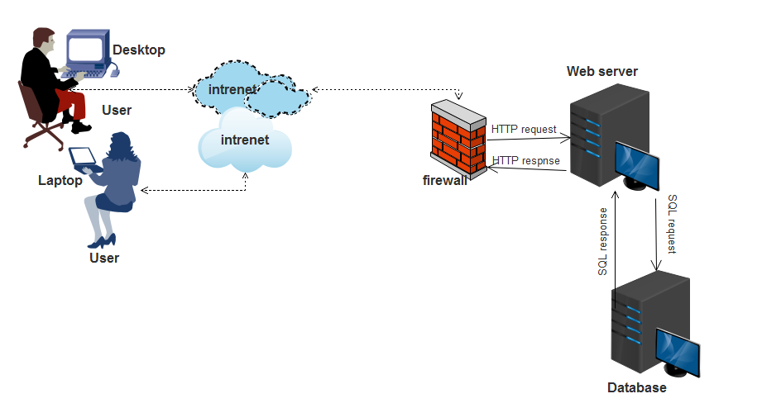

### Figures 5.2.2: Deployment diagram

# 5.3. Database design

# 5.3.1 ER Diagram Design

An Entity-Relationship (ER) Diagram is a visual representation of the database structure. It defines how data is stored, organized, and related within a system. The ER diagram uses entities (tables), attributes (columns), and relationships (links) to model the logical structure of a database.

For the Online Shopping System for Abenezar Electronics, the ER diagram is designed to capture the key data components required to manage users, products, orders, payments, and categories.

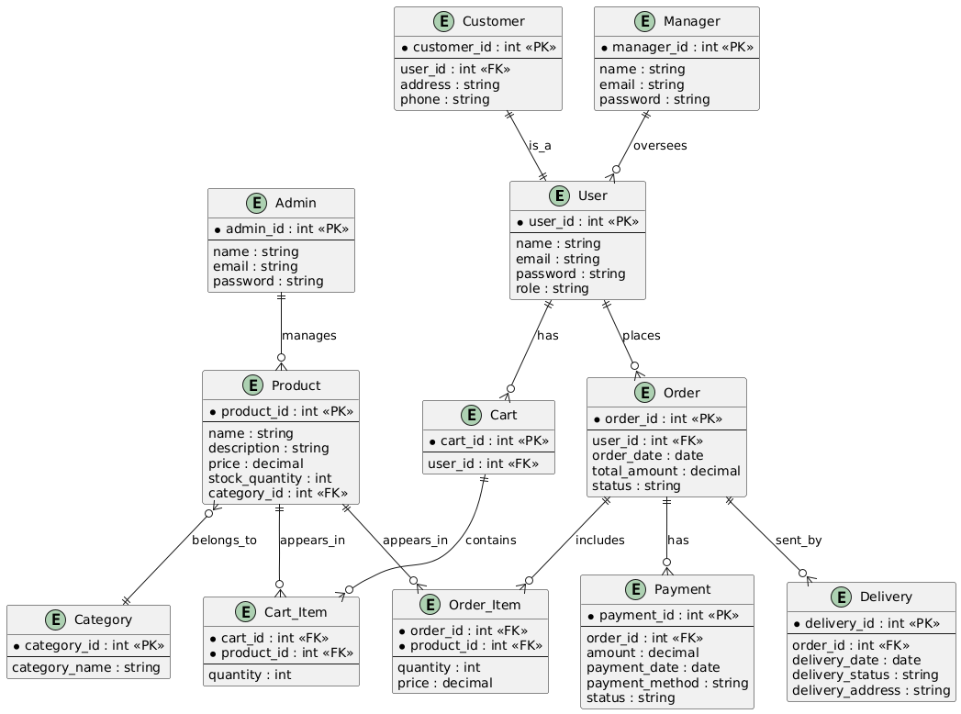

Figures 5.3.1 ER Diagram Design

### 

### 5.3.2 Database Normalization

Database normalization is the process of organizing data in a database to reduce redundancy and improve data integrity.

It involves dividing large tables into smaller, related ones and defining relationships between  
them. This ensures that the database is efficient, consistent, and easy to maintain.For the Online Shopping System for Abenezar Electronics, normalization is applied to ensure that:

Repetitive data is minimized

Data anomalies (insert, update, delete) are prevented

Data relationships are clear and logically structured

Benefits of Normalization in This System

Reduces data duplication (e.g., no repeated product or user information)

Simplifies updates and maintenance (e.g., update product info in one place)

Enhances data integrity (e.g., consistent category and payment info)

Improves storage efficiency

### Analysis class Model

Design class modeling is used to model the static structure of how the software will be built. In particular, class modeling shows classes, their internal structure, and their relationships. And also shows a collection of (static) declarative model elements, such as classes, interfaces, and their relationships, connected as a graph to each other and to their contents.

Class diagram provide a graphical notation for modeling classes and their relationship. They are concise, easy to understand, and work well in practice. Class diagrams are the backbone of almost every object-oriented method including UML.

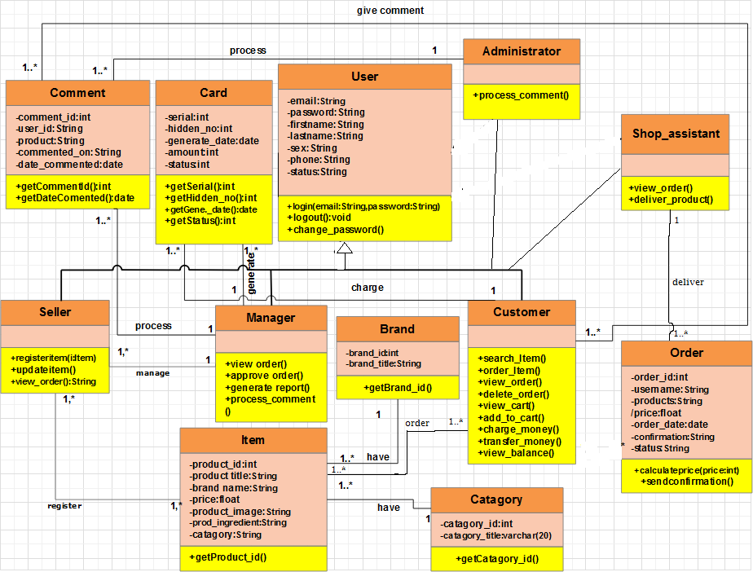

### Figures 5.3.2: Class diagram for online shopping

### 5.3.3 Persistent modeling

Persistent modeling is the process of mapping system objects to a permanent storage medium—typically a relational database—so that data can be saved, retrieved, and manipulated across multiple sessions. This ensures the persistence of data even after the system is shut down or restarted.

In the context of the Online Shopping System for Abenezar Electronics, persistent modeling defines how data from objects such as users, products, orders, and payments are translated into a database schema for long-term storage. It serves as a bridge between the object-oriented design and the relational database.

* Goals of Persistent Modeling:

To ensure long-term data storage

To map object attributes to table columns

To maintain data consistency between the application and database

To support CRUD operations (Create, Read, Update, Delete)

Benefits of Persistent Modeling:

Aligns the object-oriented model with the relational model

Facilitates data management across sessions

Enables use of ORM tools like Hibernate or SQLAlchemy (if applicable)

Improves scalability and maintainability of the system

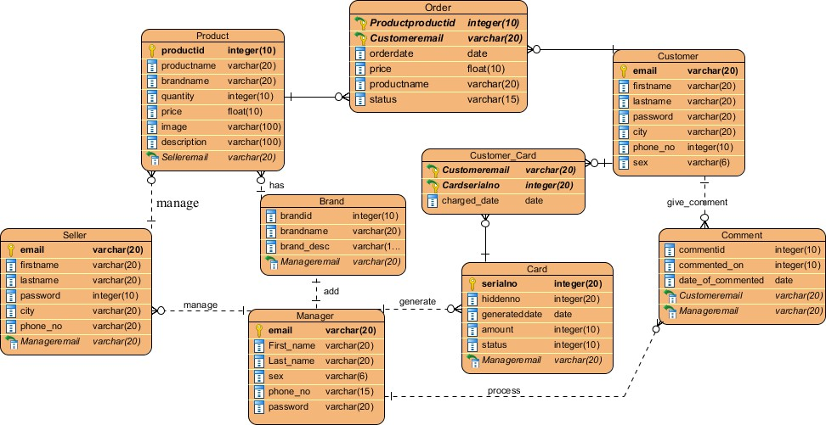

### Figure 5.3.3: Persistent diagram

## 5.4 Data flow Diagram

### Actors Customer: Interacts with the system to browse products, place orders, make payments, and track deliveries. Admin: Responsible for managing the product catalog and overseeing the backend operations of the system. Customer-Side Functional Components User Login/Register Customers can create accounts or log in to access the shopping system. Database Involved: User DB stores user credentials and profiles. Order Processing After logging in, customers can select and place orders. This process connects to several subsystems: Payment Handling: Processes customer payments through a Payment Gateway. Payment Records stores completed transaction details. Delivery Coordination: Manages product delivery through an integrated Delivery Service. Orders DB Stores all order details, linked directly to the order processing system. Admin-Side Functional Component

Product Management  
Allows the admin to add, update, or delete products in the store.  
 Product Catalog: Stores all product-related information including prices, stock, and descriptions.  
**External Systems**  
Payment Gateway: A third-party service that securely handles online payment transactions.  
Delivery Service: An external or internal logistics system used to deliver orders to customers

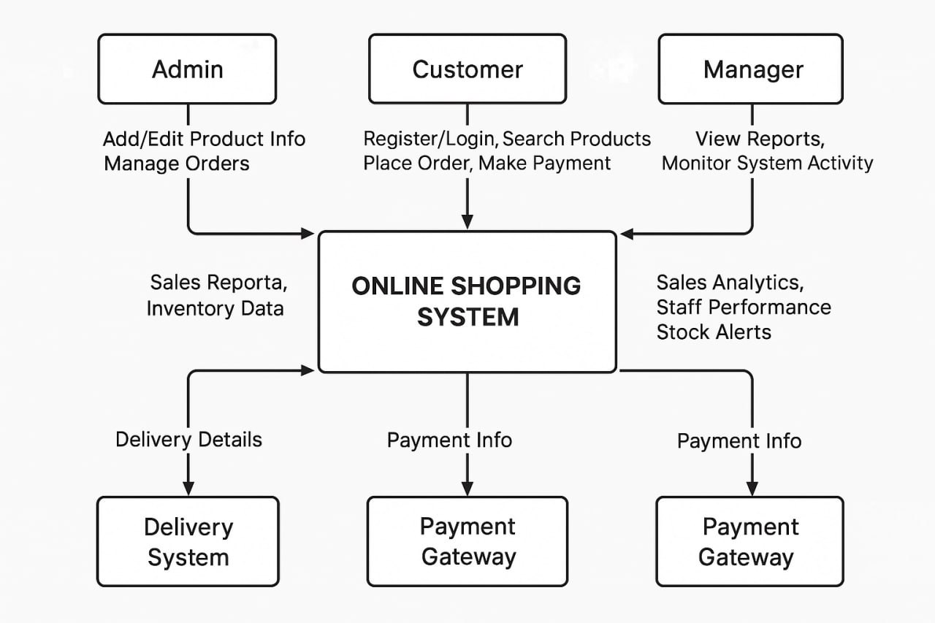  
  
  
  
 Figures 5.3.4 Data flow Diagram

# Appendices

* Sample Questionnaire Used for Data Collection  
  For Staff:  
  1. How do you record customer purchases?  
  2. How do you manage and check stock levels?  
  3. What issues arise from manual tracking?  
  4. How often is stock updated?  
  5. How do you communicate product availability?  
  6. Are transaction records searchable?  
  7. What reports do you generate manually?  
  8. What digital features would improve your tasks?

For Customers:  
1. Frequency of shopping at Robe Electronics?  
2. Are you satisfied with the current system?  
3. Issues with stock availability?  
4. Would you prefer online shopping?  
5. Desired features in the new website?  
6. Contact methods used?  
7. Comfort with online payments?  
8. Importance of delivery track

# References

Chaffey, D. (2019). *Digital business and e-commerce management.* Chaffey, D. : Pearson Education Limited.

Laudon, K. C. (2020). *Management information systems.* london: Pearson Education.

R. S., &. M. (2014). *Software engineering.* Pressman: McGraw-Hill Education.